<https://youtu.be/6wf5dIrryoQ?si=qk_LY16FBOEODU2X>



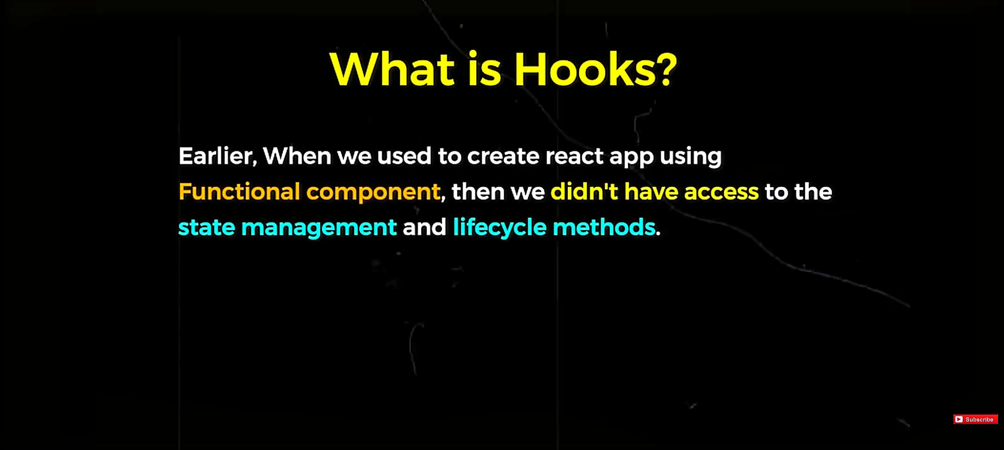

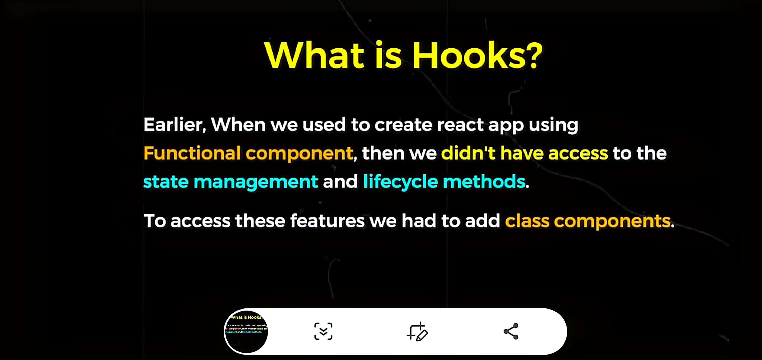

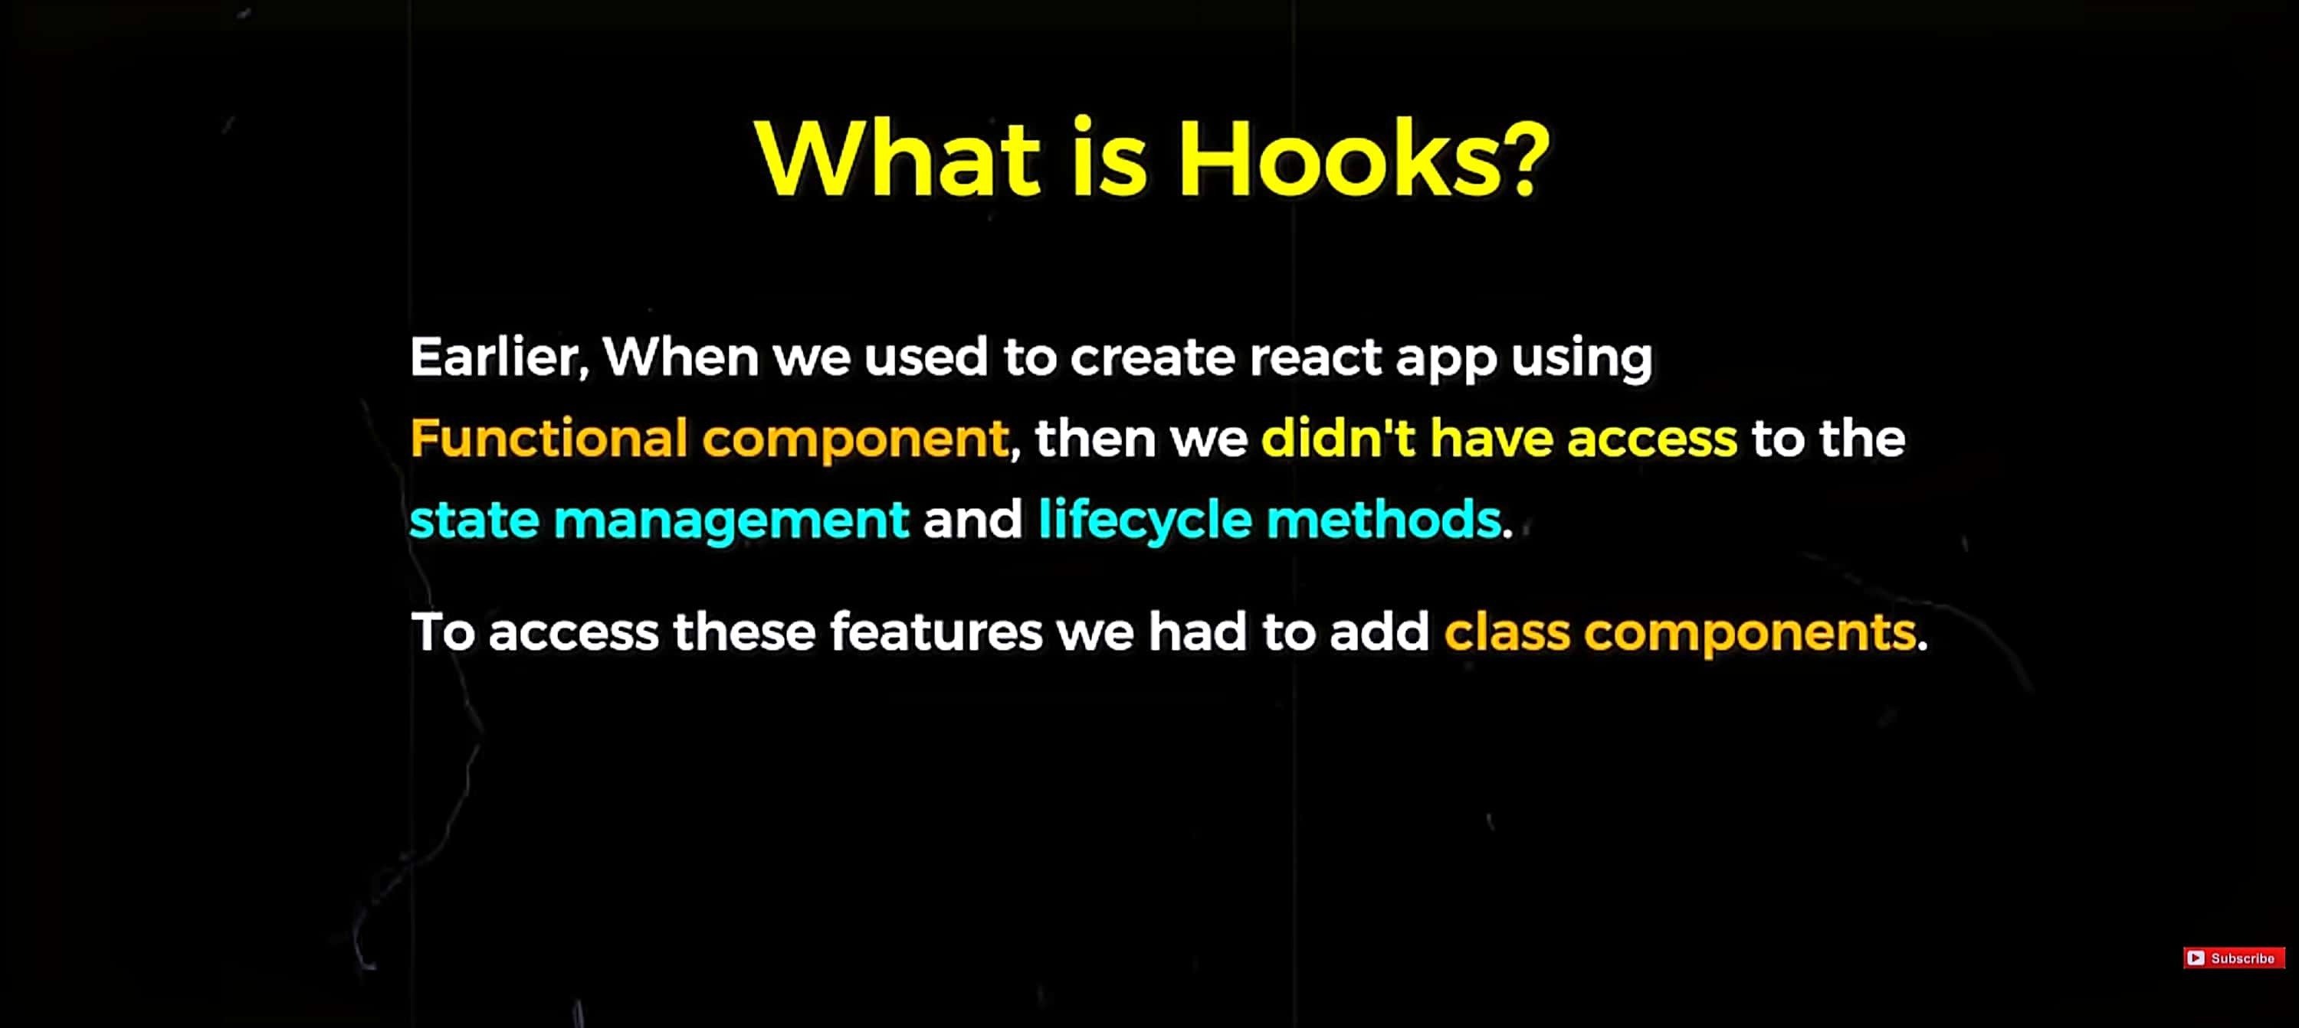



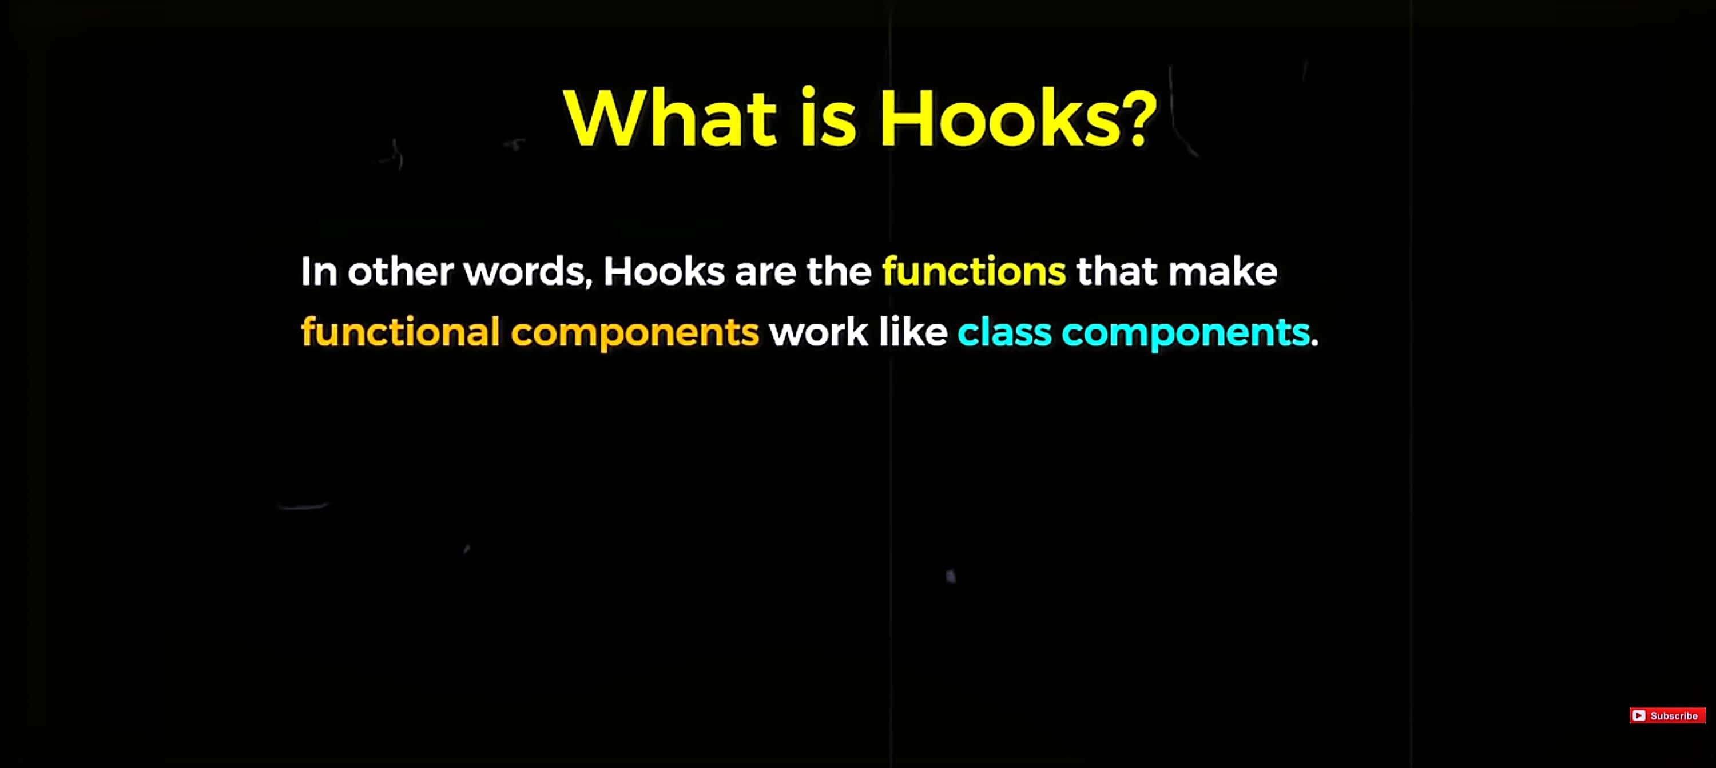

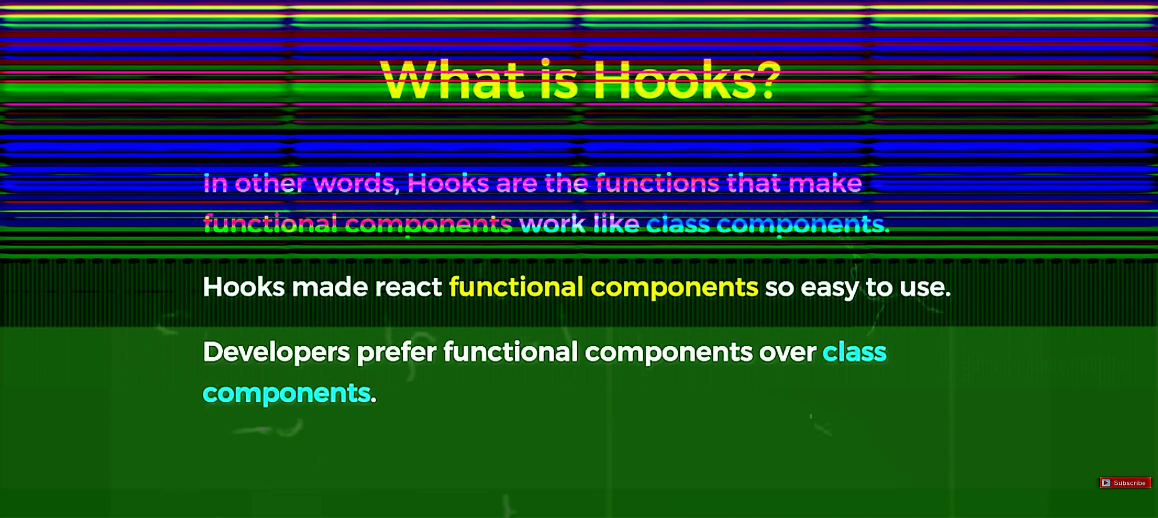



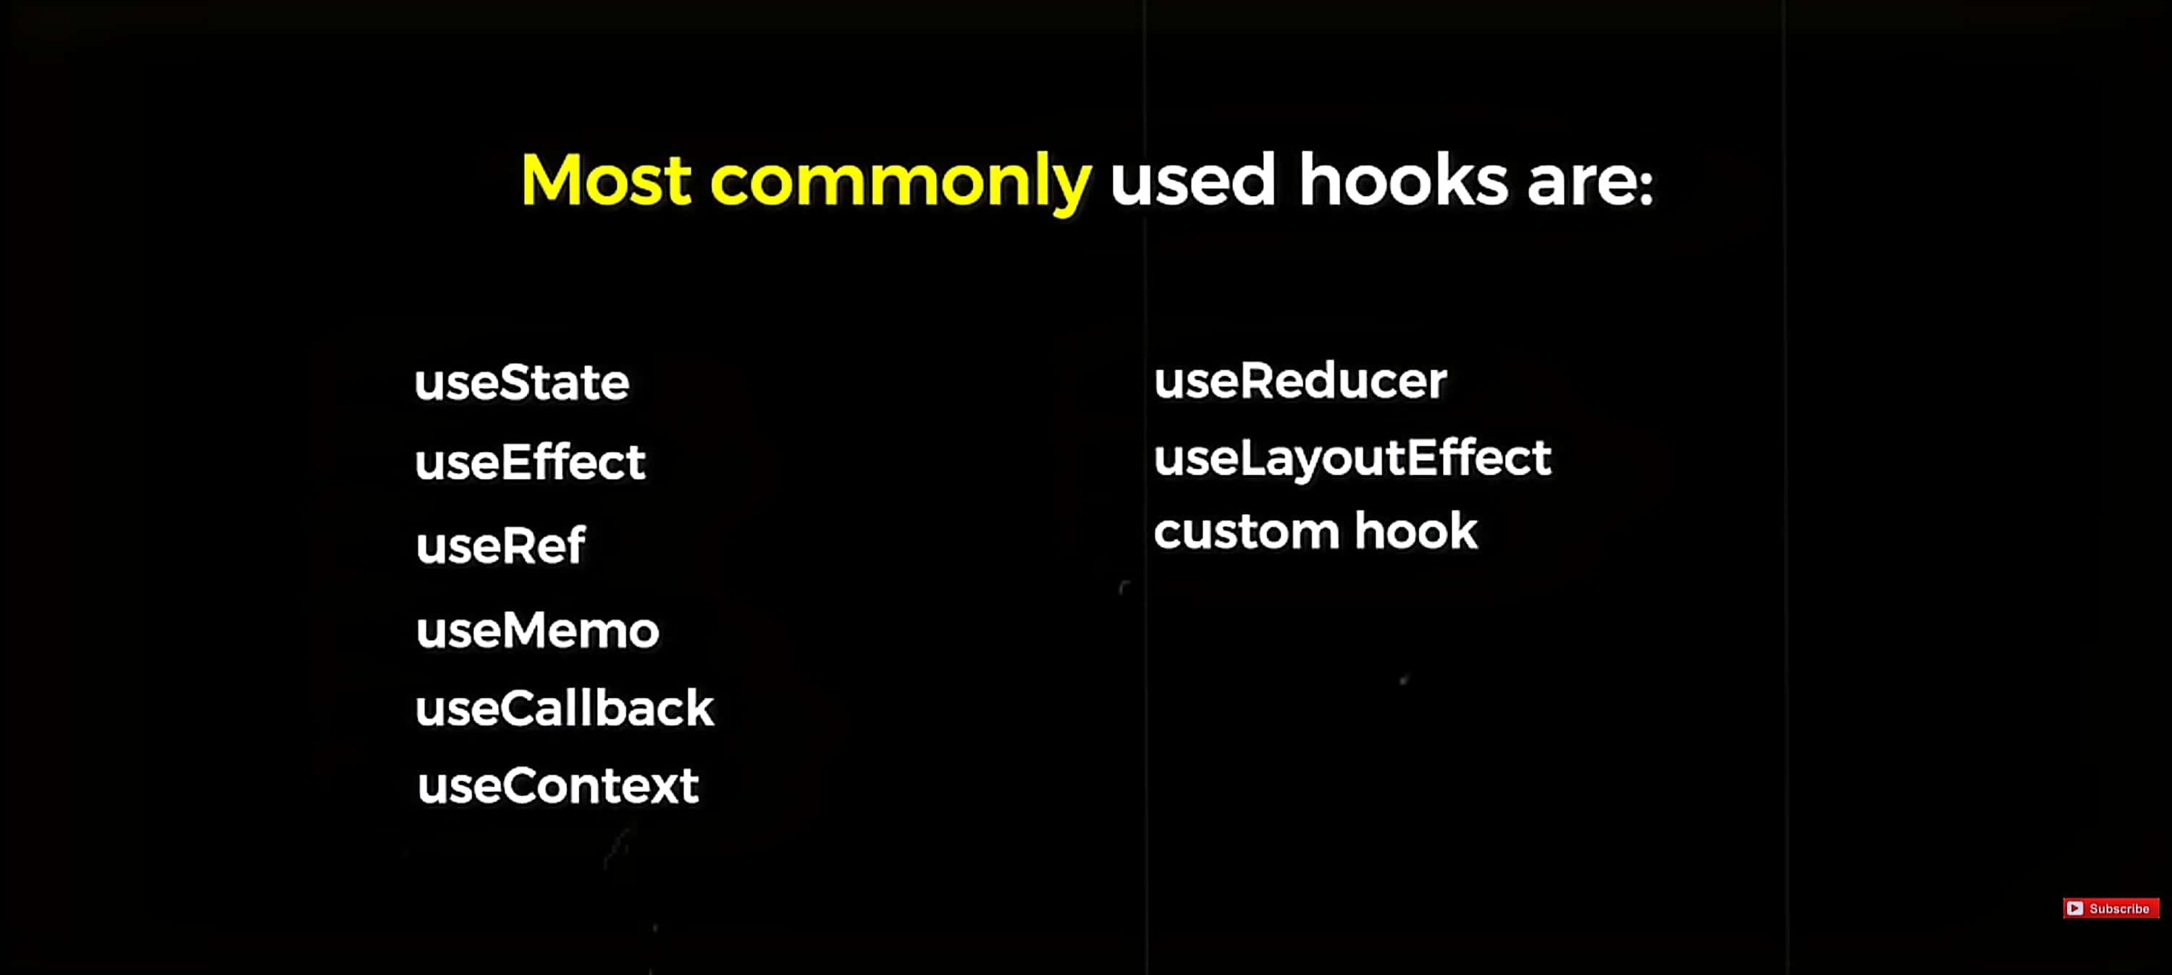

# 

# Use State hook

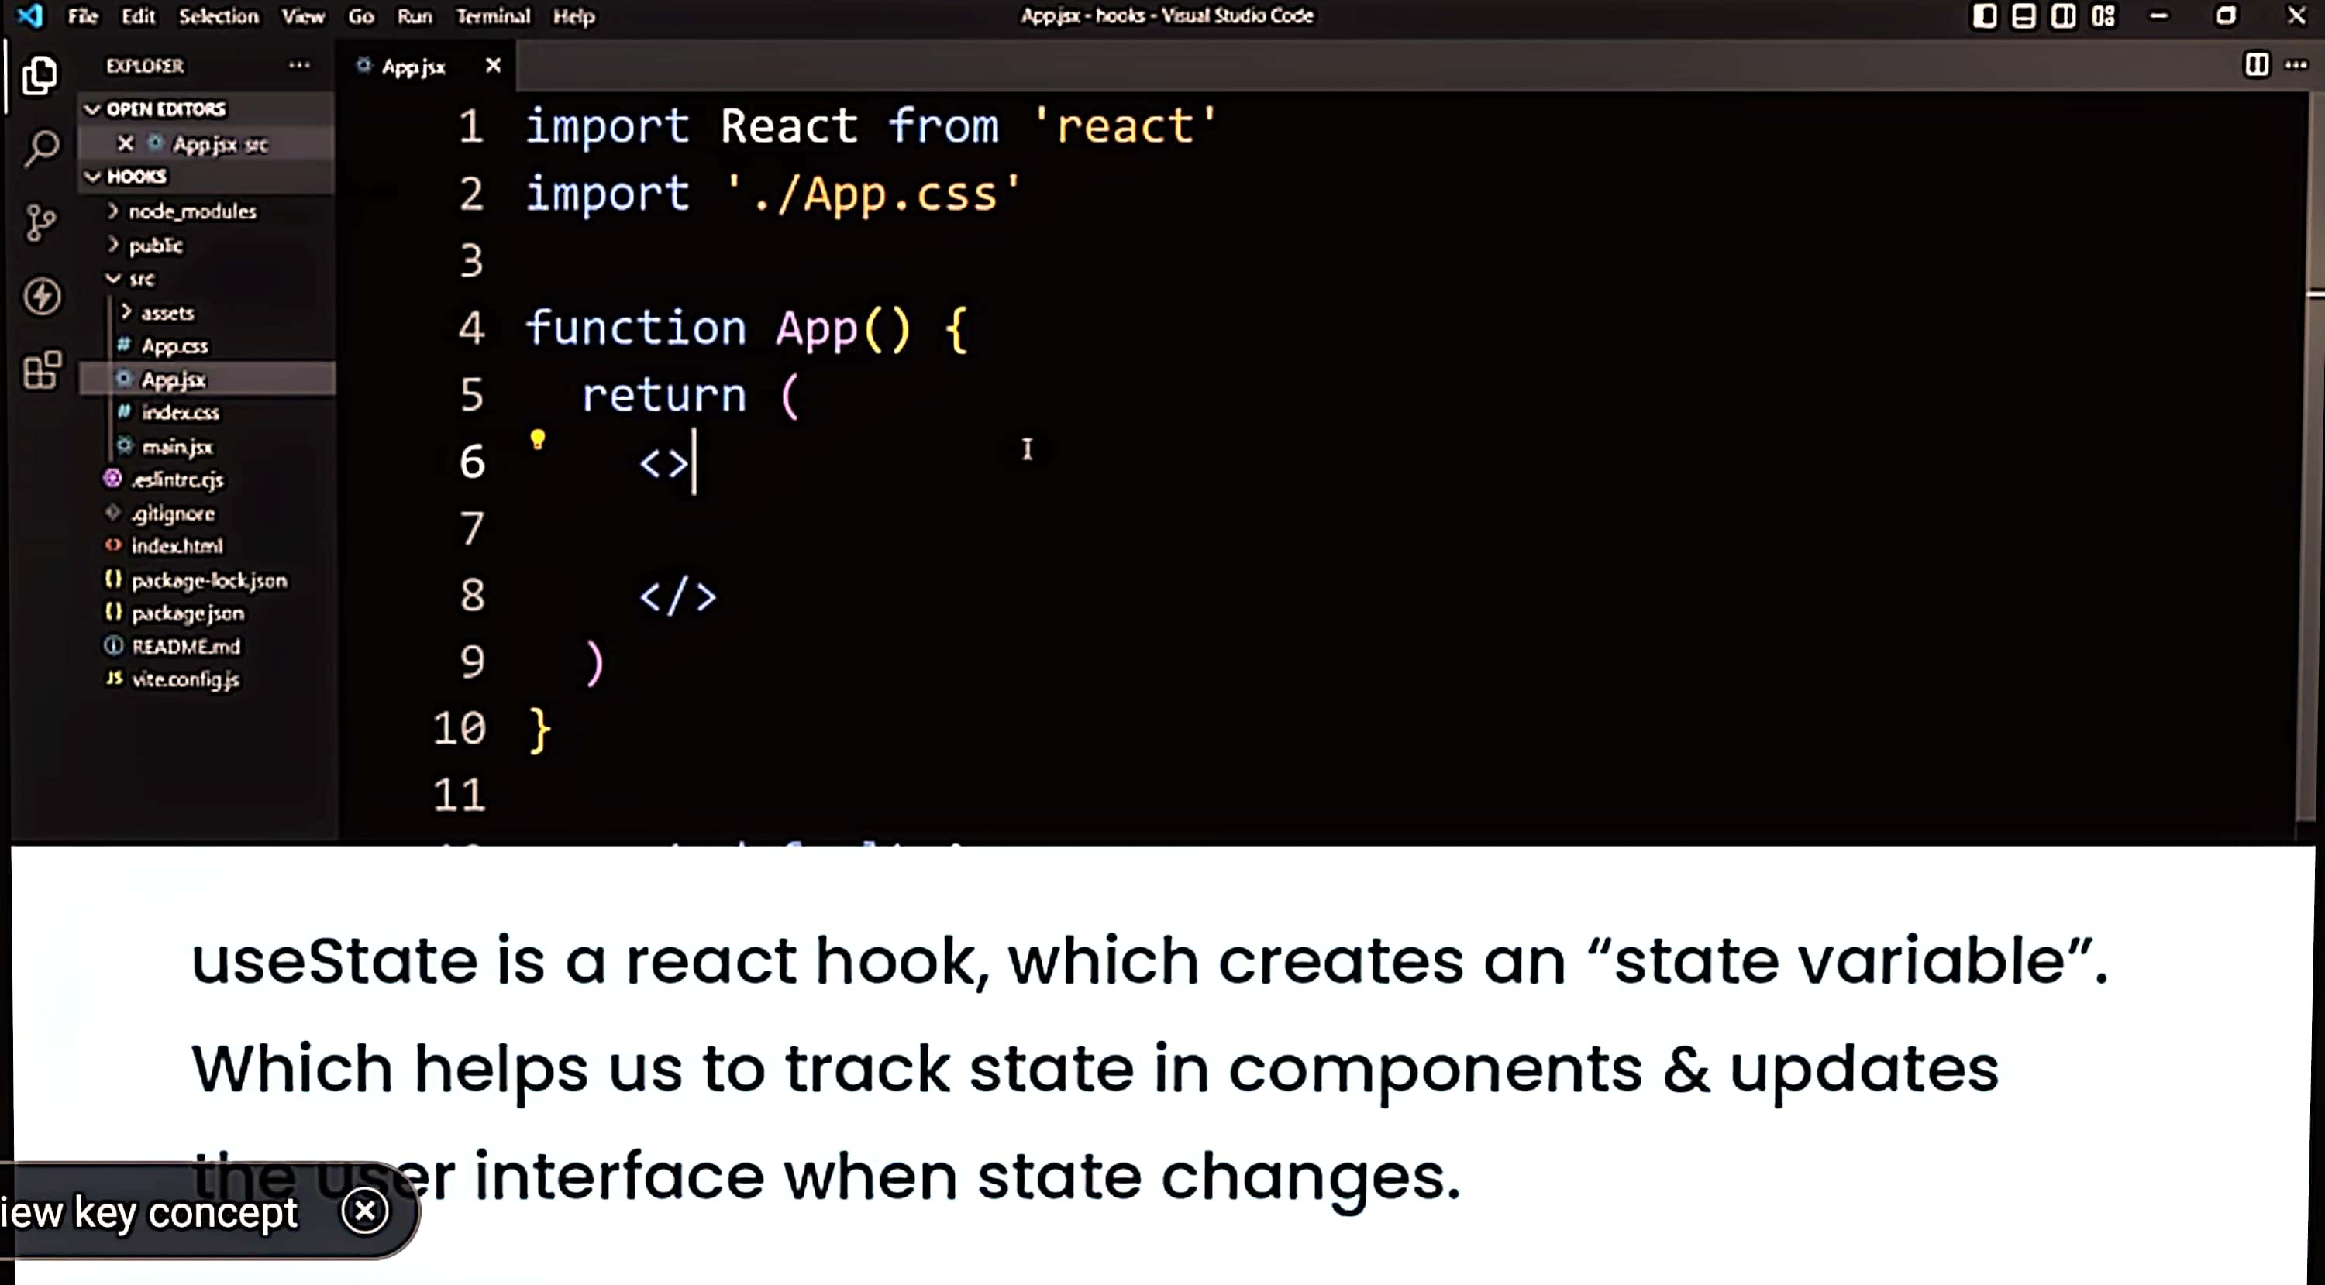

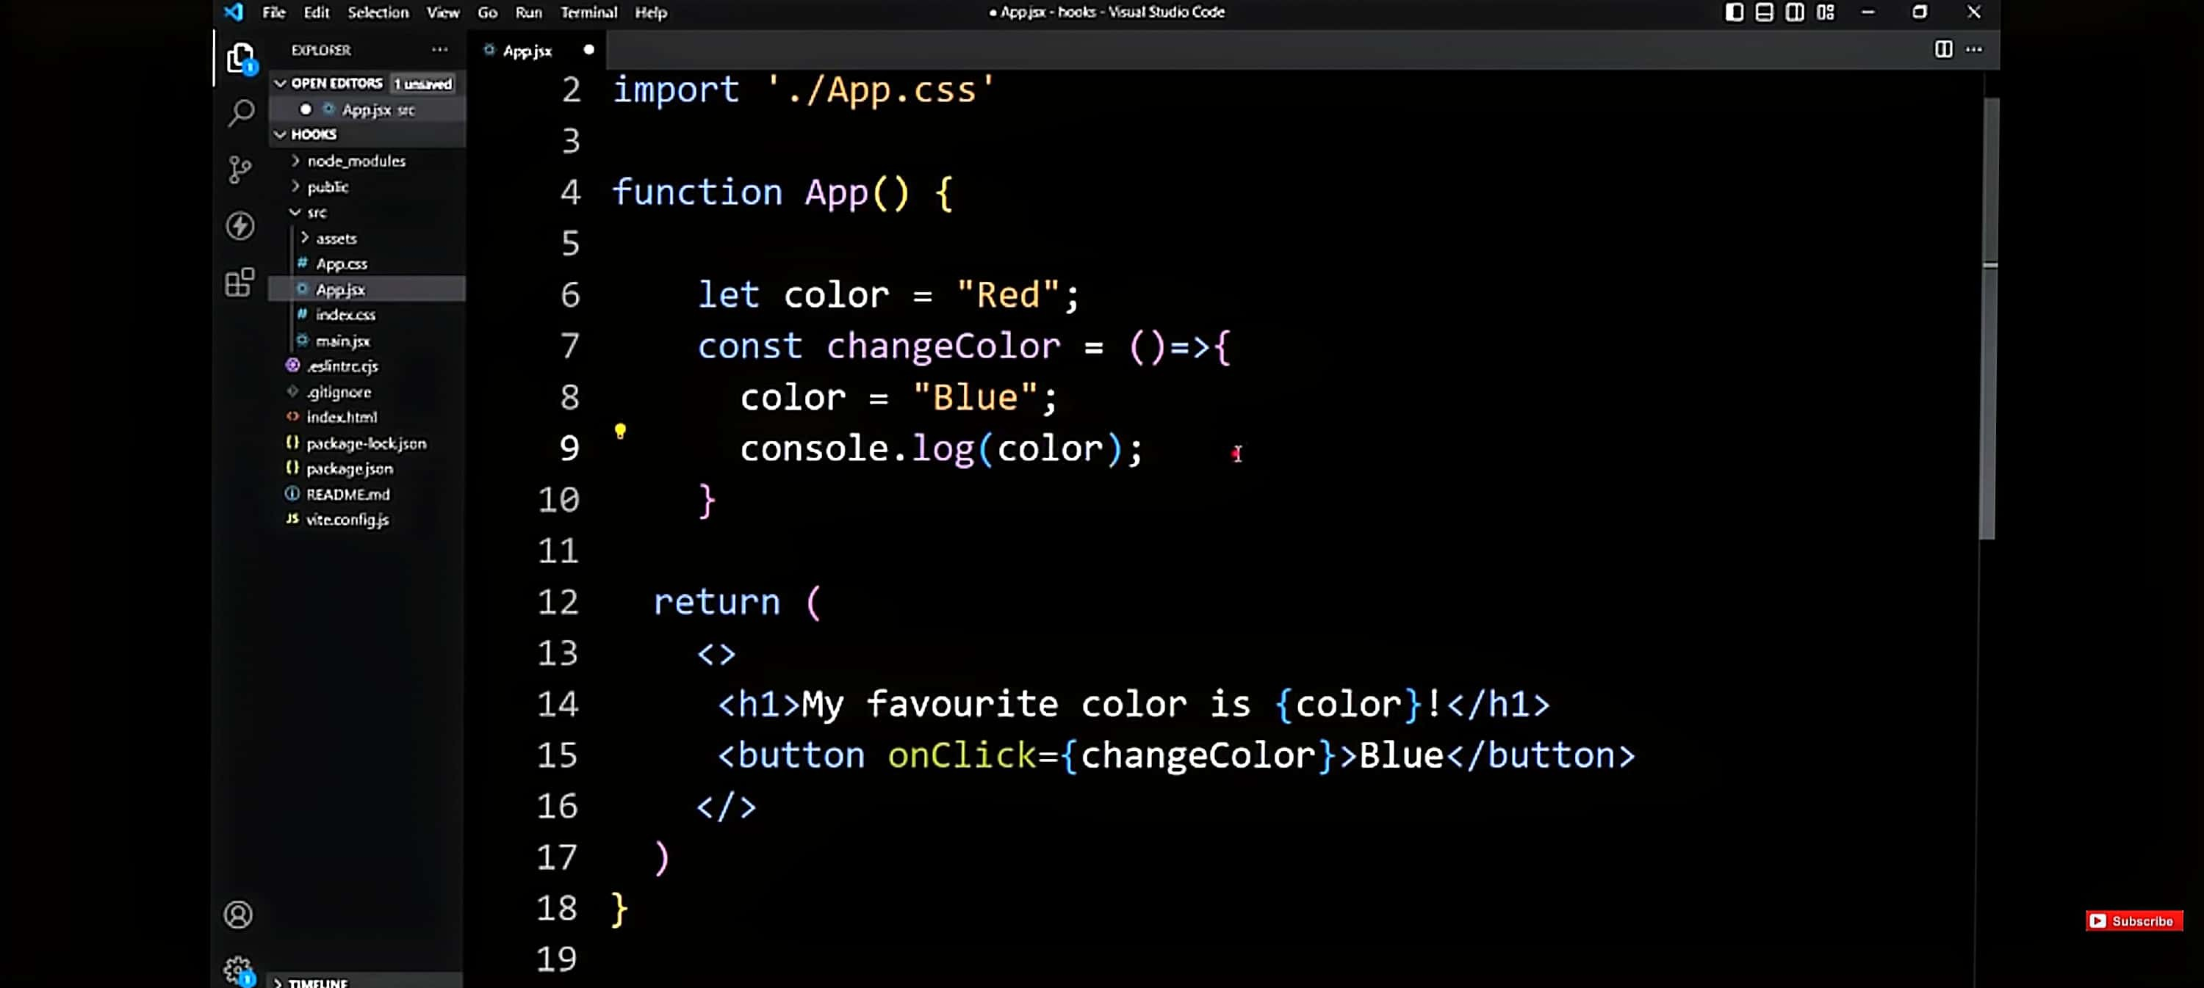

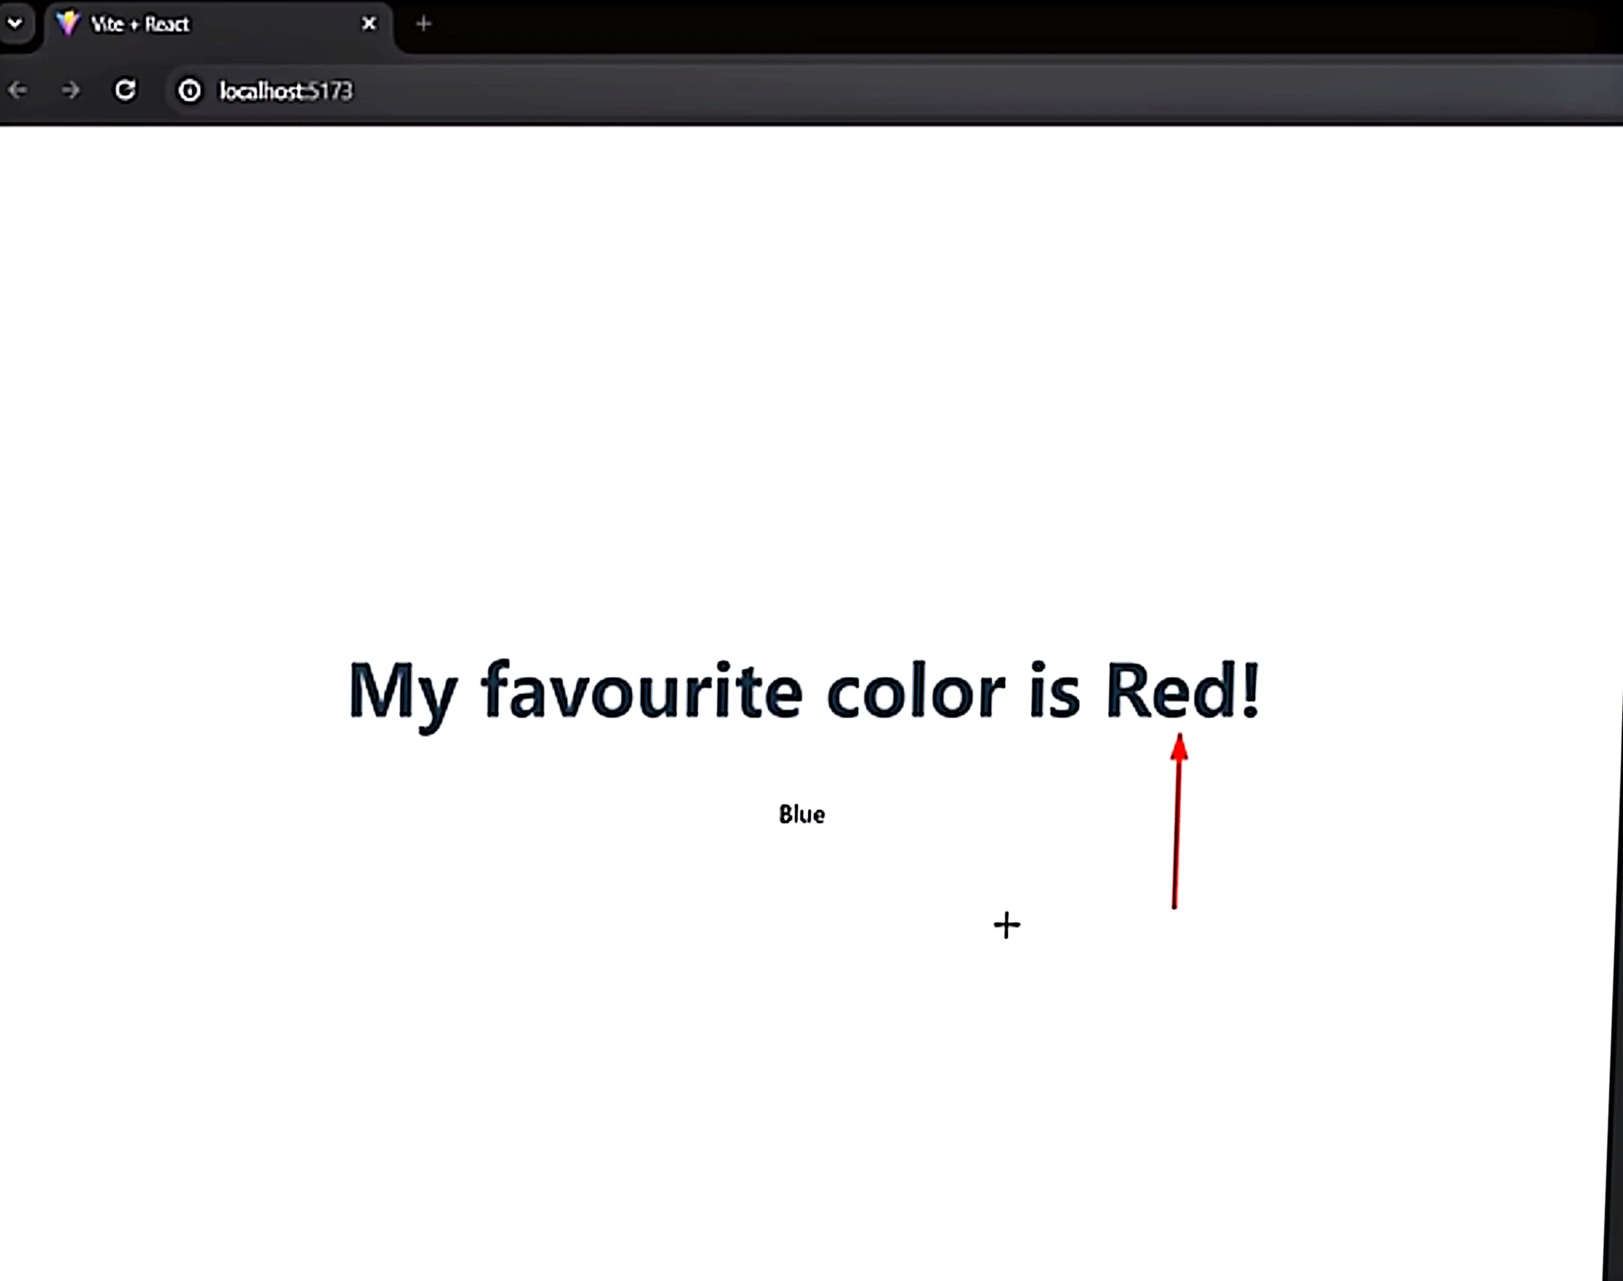

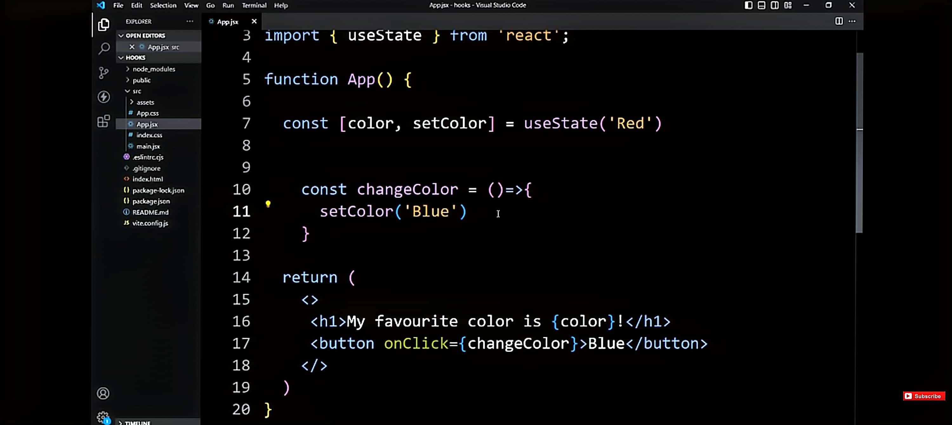

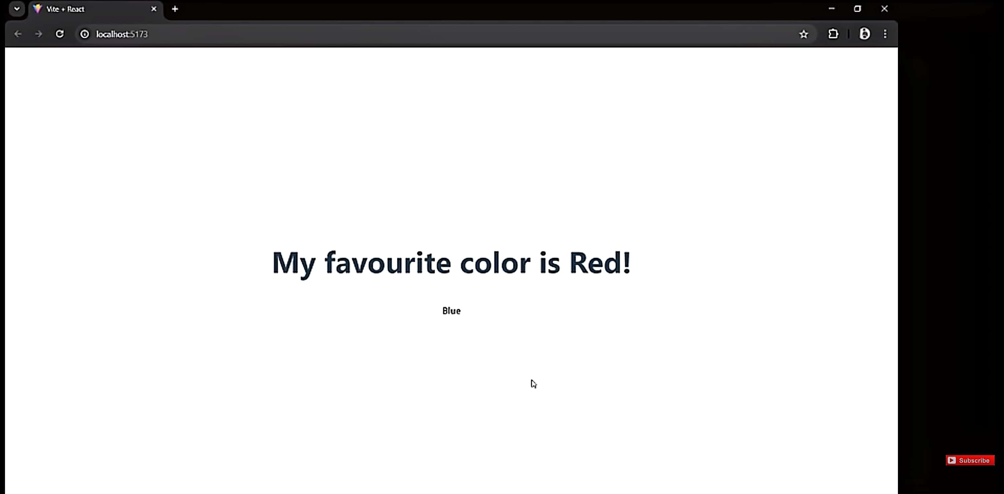

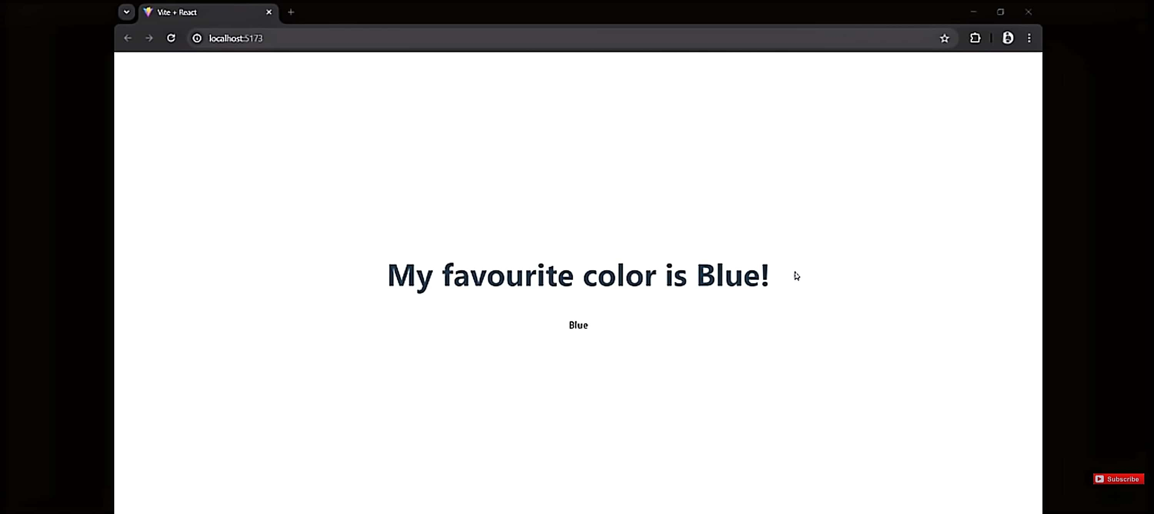

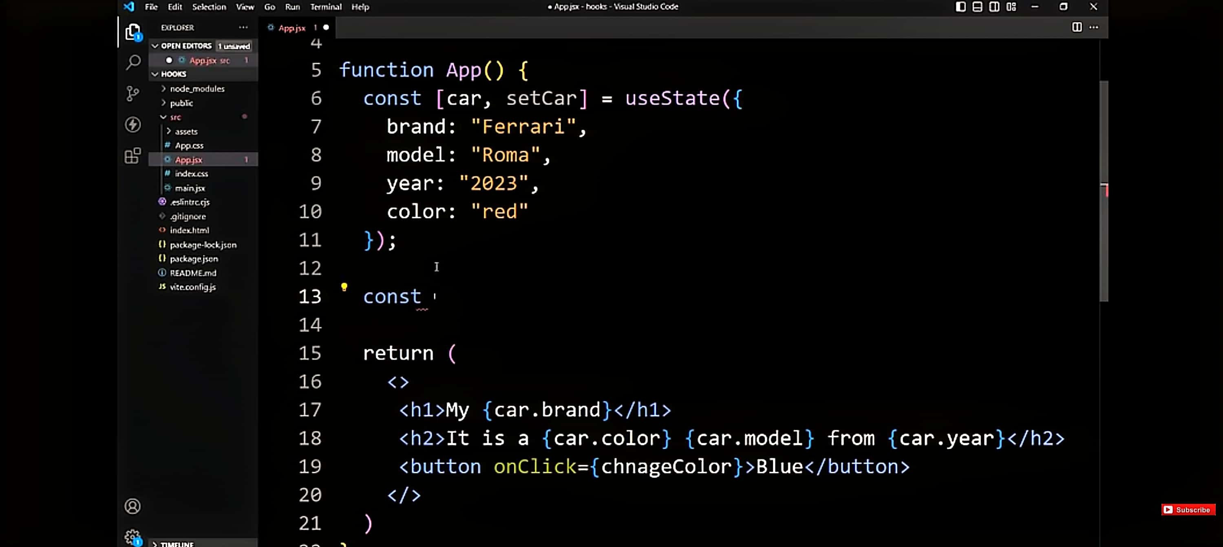

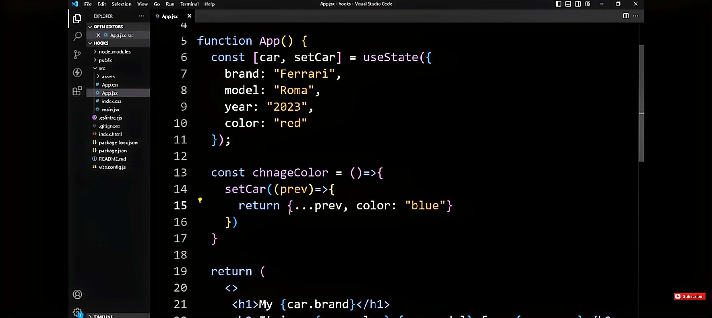

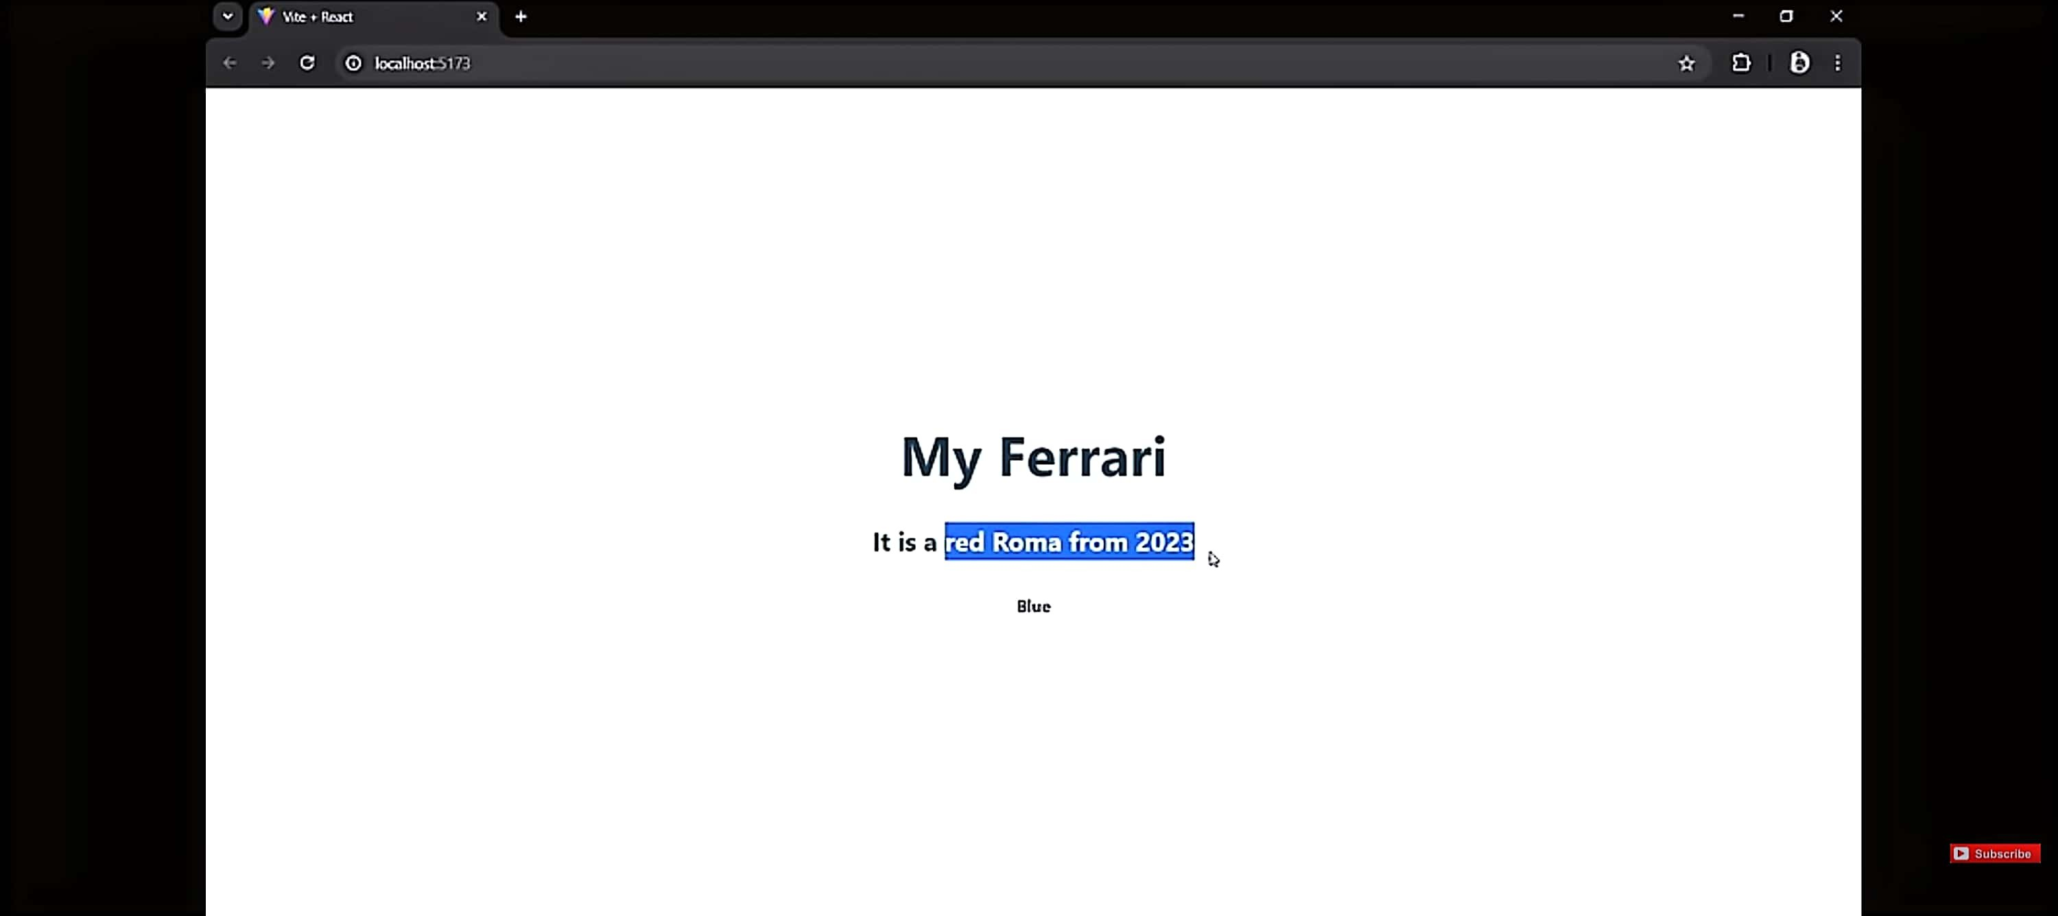

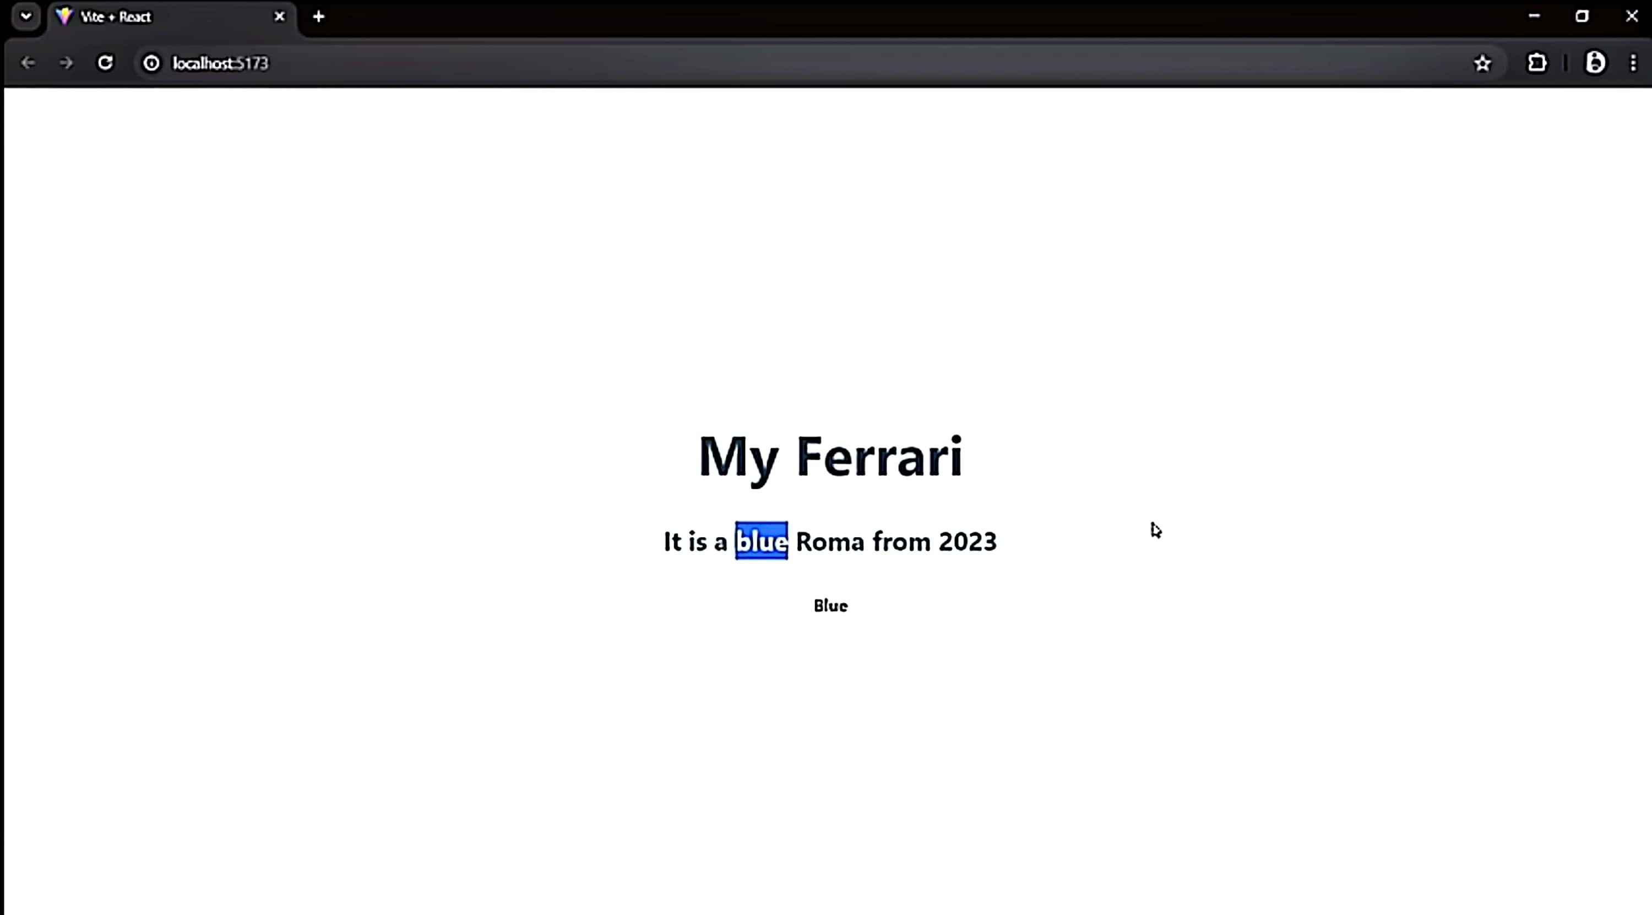

N MD

## Exampe 3:

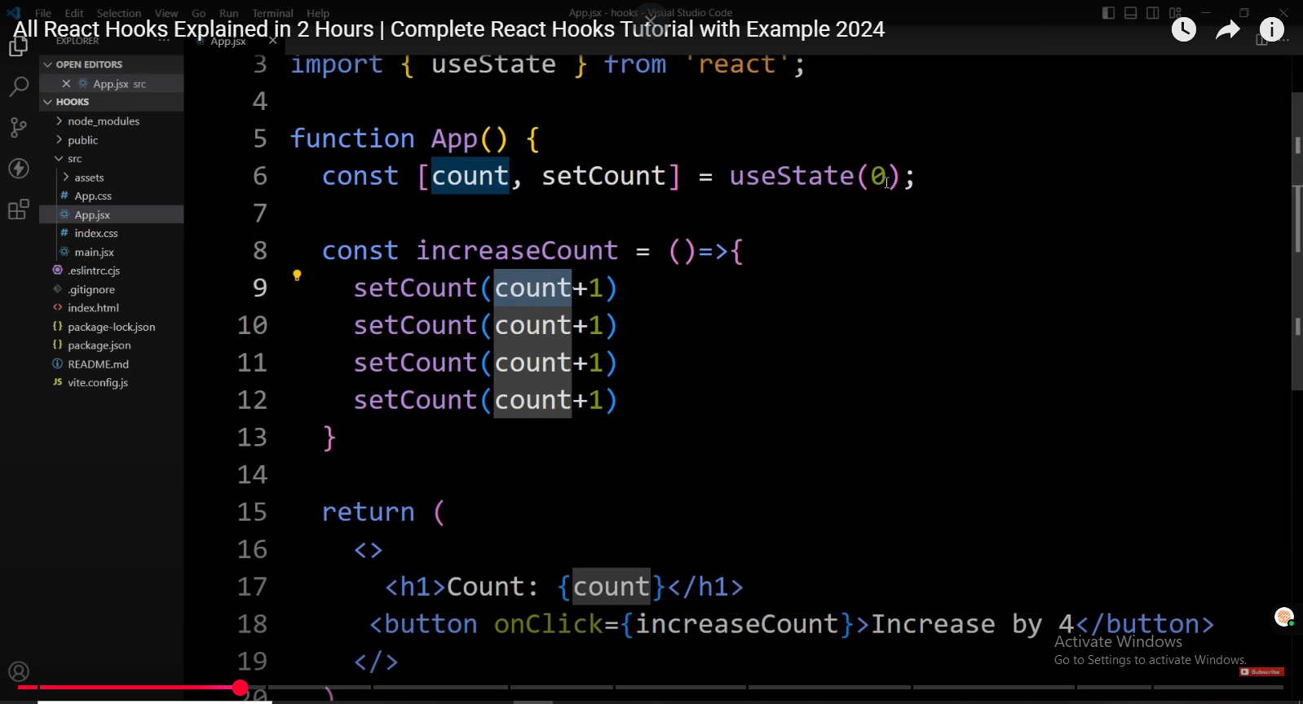

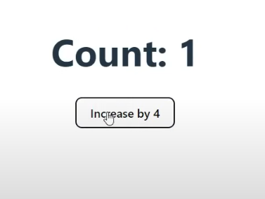

Unexpected : it still increase it by 1 not 4, b/c its in running state and its not updating UI  
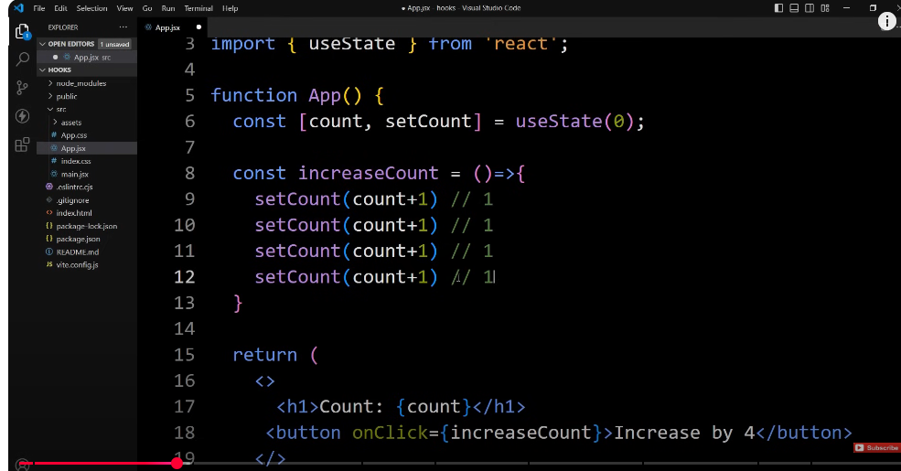

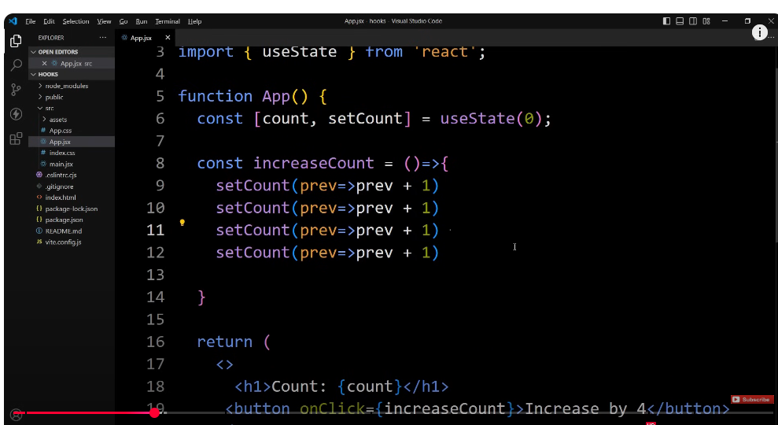

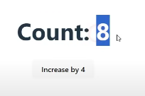

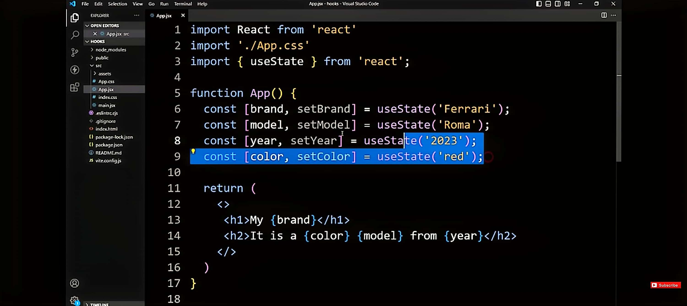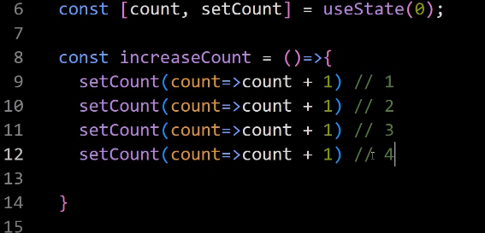

# USEEFFECT HOOK

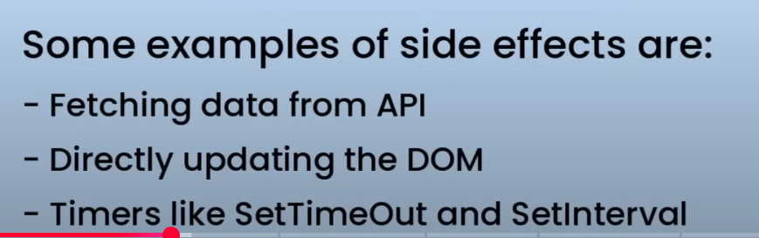

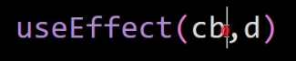

USEEFFFECT use call back function and dependency array, cb is req but dep is optional

## Three ways:

1. 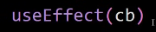 🡪 without any dependency
2. 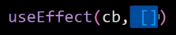 🡪 using empty array
3. Add number of variables in array with seperated comma

## CASE 1: UseEffect , no dependency is provided , only call back function

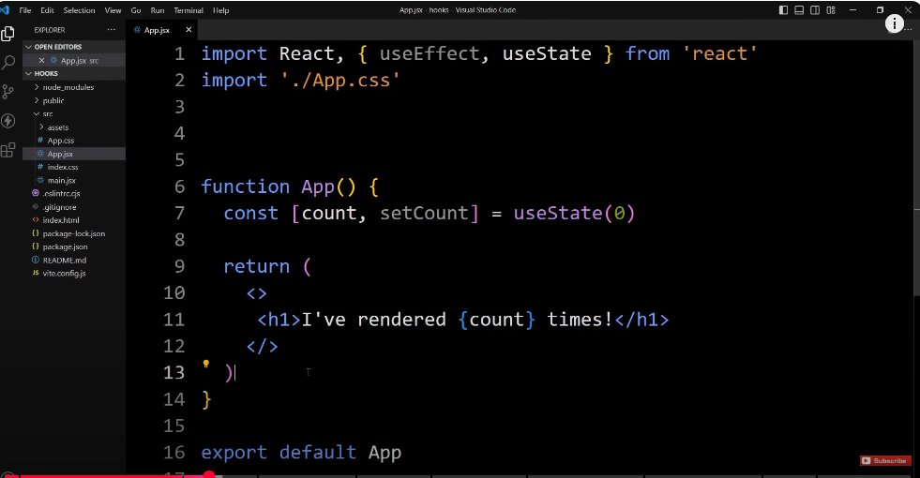



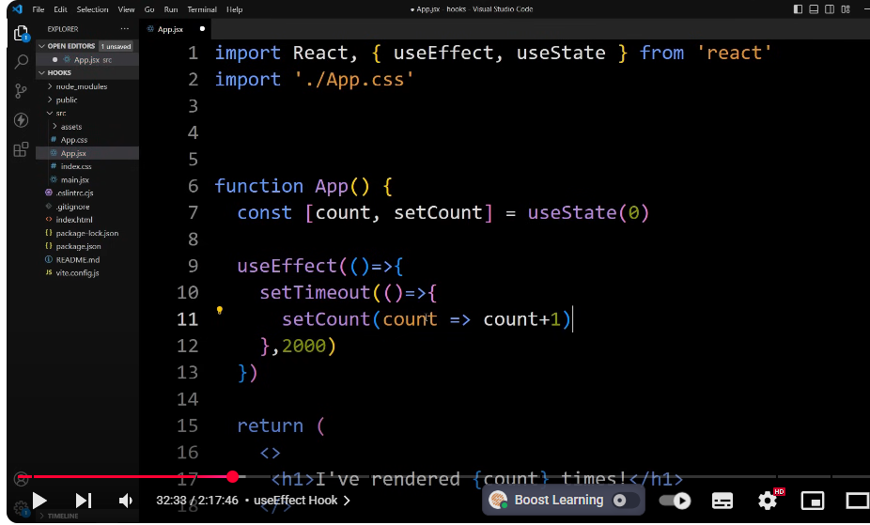







Problem: it directly goes from 0 to 2, not 1  
reason: React StrictMode 🡪 additional runtime checks in the development environment to make sure your app is safe , remove it from main.jsx

Now this problem has been resolved , after every 2 sec UI is being updated

setTimeOut shoud run only once , but value i updating continuously b/c we have put in UseEffect without any dependency, so it will execute call back func which is setTimeout here

whenever any state changes in component

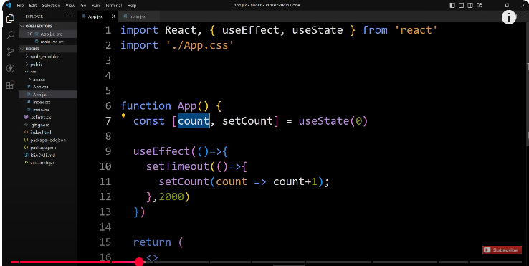

So here count state is being changed after 2 sec, and when count state chnages , useEffect again execute call back function

## Case 2: UseEffefect with empty Dependency array

UseEffect will only execute call back function once when the component is loaded.

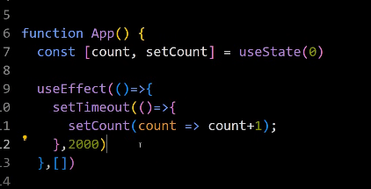

## Case 3: when there is one or more variables in dependency array

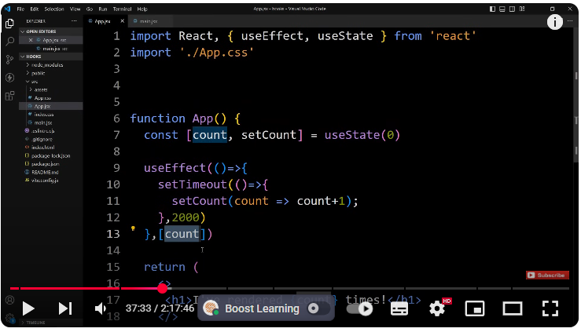

Jab jab count ki state change hogi useEffect run hoga  
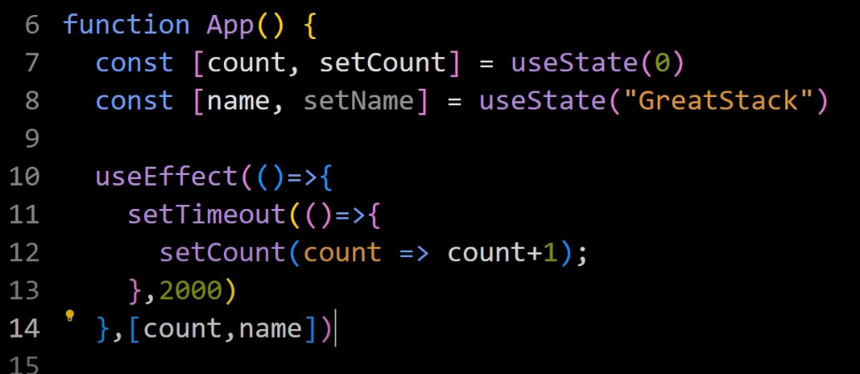

We can add multiple states in dependency array

# useRef:

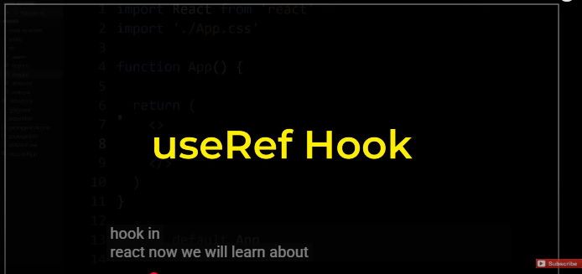

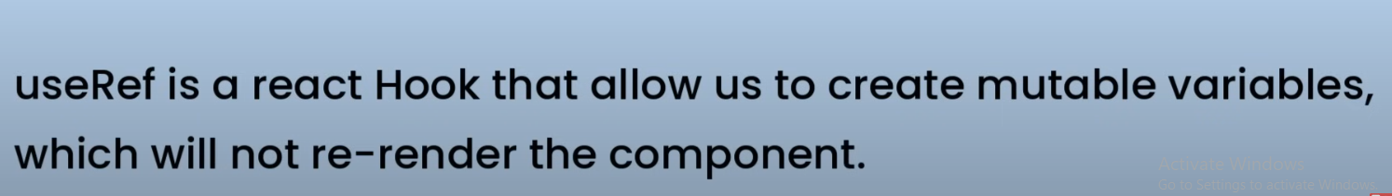



"useRef kuch change karta hai, lekin component re-render nahi hota?"

"Kya ye state jaisa hai? Ya DOM ka reference?"

## ✅ useRef Kya Hai? — Ek Line Mein:

**useRef ek aisi box hai jisme aap kuch bhi rakh sakte ho — bina component ko dobara render kiye.**

## 🔥 Jab useState se Farq Samajh Aayega — sab kuch clear ho jaayega:

| **useState** | **useRef** |
| --- | --- |
| Value change hone pe component **re-render** hota hai | Value change hone pe component **re-render nahi** hota |
| UI ke liye use hota hai | Mostly background cheezon ke liye use hota hai |
| **state = visible** | **ref = invisible (secret memory)** |
| React ke control mein hota hai | React usse ignore karta hai |

## 🧠 Socho useRef ek **pocket** hai:

js

CopyEdit

const box = useRef(); // 👈 Pocket ban gayi

js

CopyEdit

box.current = "Ali"; // 👈 Pocket mein "Ali" rakh diya

js

CopyEdit

console.log(box.current); // 👈 Kabhi bhi check kar sakte ho

## 🔁 But kyun use karein useRef?

### ✅ 1. DOM Access (Input focus, scroll, etc.)

js

CopyEdit

<input ref={inputRef} />

inputRef.current.focus();

### ✅ 2. Kuch value ya variable track karna bina render

js

CopyEdit

prevCountRef.current = count;

### ✅ 3. Timer ID ya any reference save karna

js

CopyEdit

timerRef.current = setInterval(...)

## 🔍 Real-Life Analogy:

**useState = Whiteboard (sab ko dikhta hai, change hone pe sab ko pata chalta hai)**  
**useRef = Pocket Diary (aap kuch bhi likh lo, baaqi ko pata nahi chalta)**

## ✅ Jab use karna chahiye?

| **Situation** | **useRef Ya useState?** |
| --- | --- |
| UI dikhaani ho | useState |
| DOM element pe kaam ho | useRef |
| Previous value store karni ho silently | useRef |
| Timer ID ya mutable value store karni ho | useRef |

## 📍 Final Tip:

Agar tumne kabhi React ke andar document.getElementById() use kiya — to uska **React version** hai: useRef.

## 🎯 **How to Explain** useRef **in an Interview:**

"useRef is a React Hook that lets us create a **mutable reference** to store any value — including DOM elements — **without triggering a re-render** of the component."

### ✳️ Break it down for the interviewer:

### ✅ 1. **Why useRef exists?**

"In React, we use useState when we want React to re-render the UI on value change. But sometimes, we need to store a value **without causing re-renders** — like a timer ID, previous state, or a reference to a DOM element. That’s where useRef helps."

### ✅ 2. **What does it return?**

"useRef() returns an object with a .current property, and we can read/write to this property anytime."

### ✅ 3. **Common use cases:**

* **Accessing DOM elements:**

jsx

CopyEdit

const inputRef = useRef();

<input ref={inputRef} />

useEffect(() => {

inputRef.current.focus();

}, []);

“This is like replacing document.getElementById() in React — but the React way.”

* **Tracking previous values:**

js

CopyEdit

const prevCount = useRef();

useEffect(() => {

prevCount.current = count;

}, [count]);

"Since useRef is preserved across renders and doesn’t reset, it’s perfect for remembering old values."

* **Storing timer IDs or mutable variables:**

js

CopyEdit

const timerId = useRef();

timerId.current = setInterval(...);

“We store things like setInterval IDs in refs so we can clear them later, without rerendering the component.”

## ✅ Final Interview Line (to end your answer):

"useRef is best when I want to store something that needs to persist across renders — like a DOM node, a timer ID, or a previous value — **but I don’t want it to trigger re-renders like useState would**."

## 🧠 Bonus Tip:

If interviewer asks "When not to use useRef?" — You can say:

"If the value needs to reflect in UI or should trigger re-renders, I’d use useState instead. useRef is better for background, hidden memory."

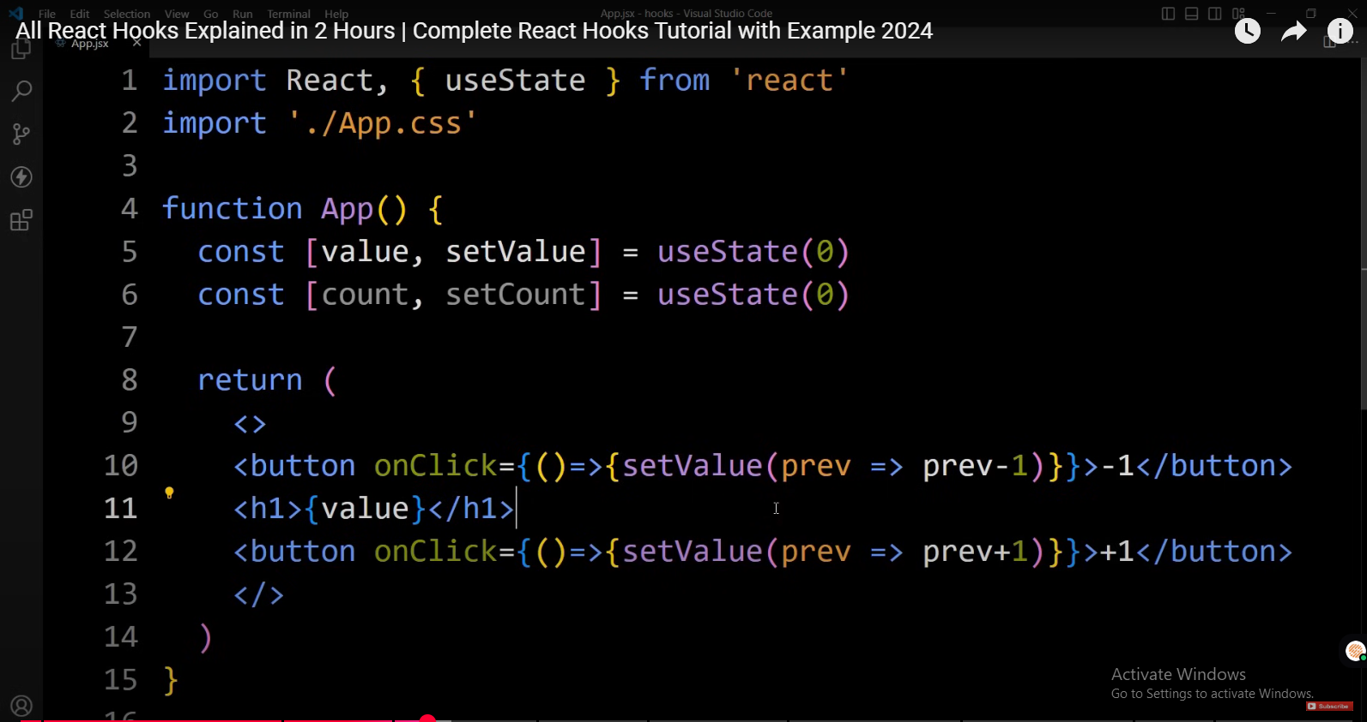

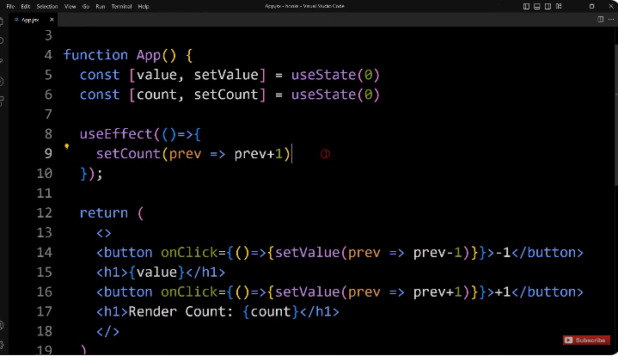

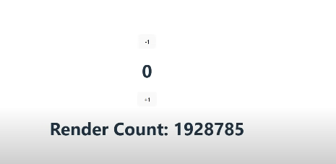

add H1 tag and we will add render

42:40

count just insert this count that we have

42:45

created using user state so till now we are not using the Useref we are using

42:52

UseState so let's see what happens here we have render count

42:58

zero right next we have to increase this count whenever the component gets

43:04

rendered so here let's add use

43:11

effect click from this snippet so it will import this use effect from react

43:18

library now in this one we will add one add

43:24

function and use this set count

43:29

here we will take the prvious value and uh increase the previous value

43:36

by one so previous + one in this use effect I'm not using any dependencies so

43:44

what will happen so when we use this use effect without dependency then this

43:49

function will be executed whenever any state changes so save this changes and

43:55

let's open the web page so you can see this counter is increasing continuously so here we are

44:03

facing one issue this counter is increasing continuously so it will run

44:08

this counter in infinite Loop this problem is happening because user State

44:14

itself causes rendered

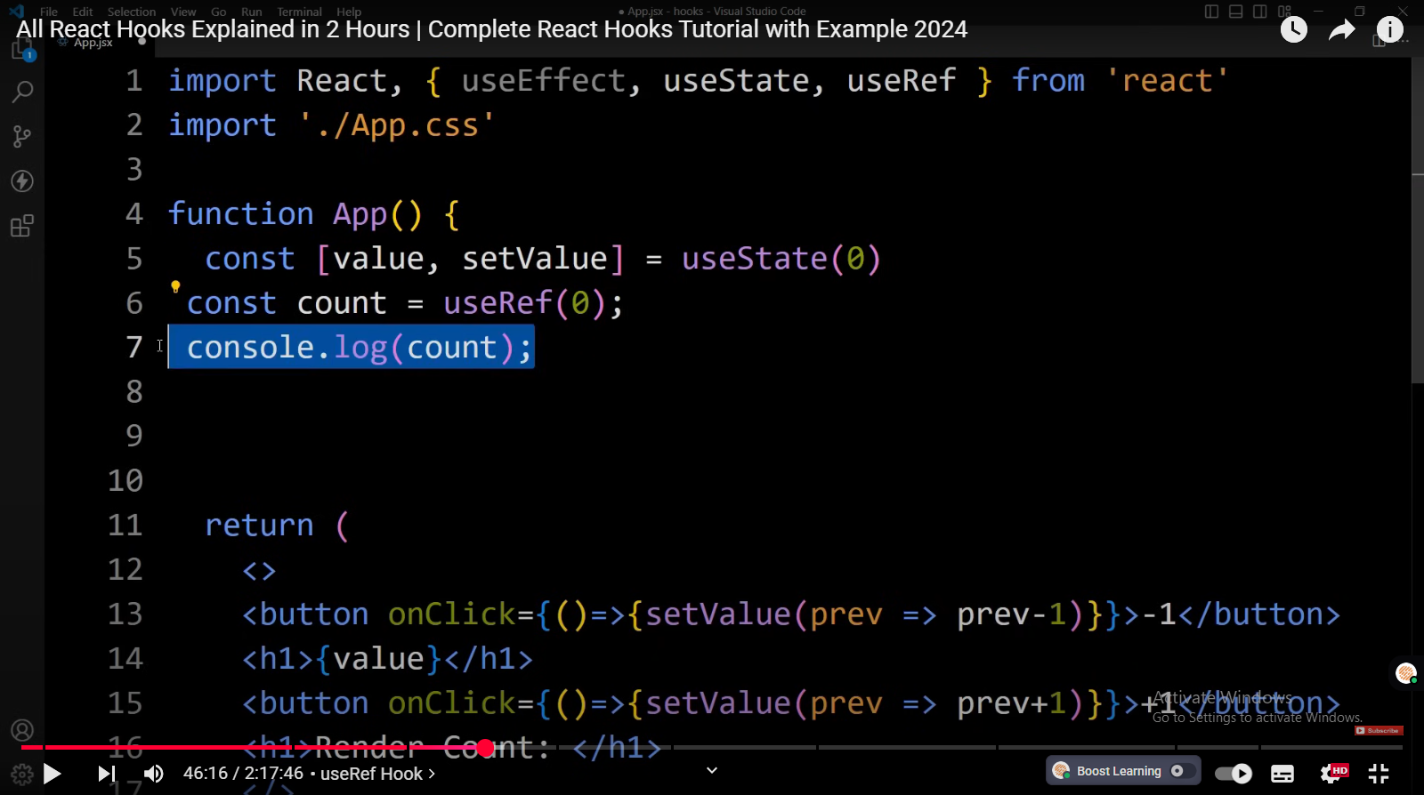

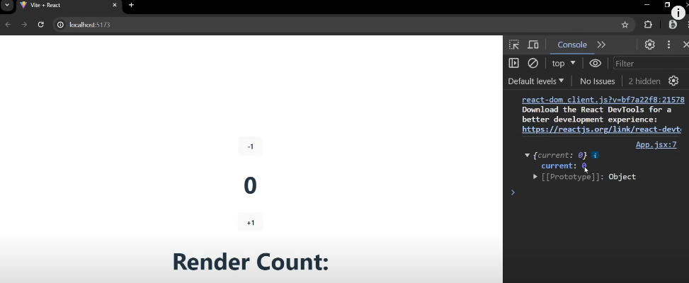

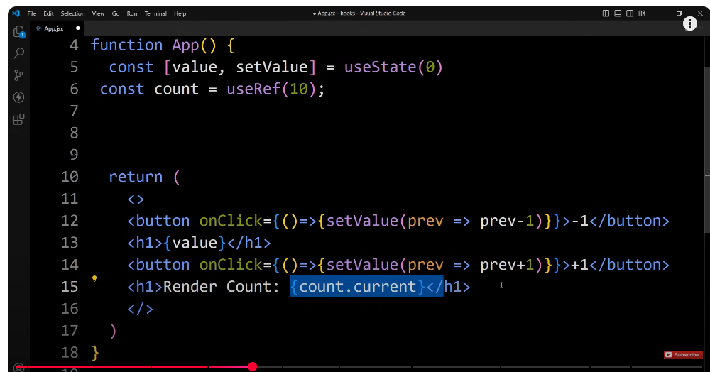

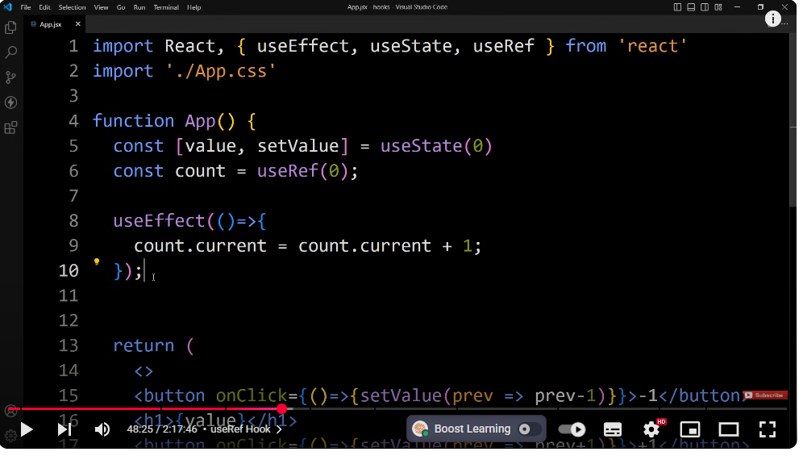

this use ref is not rendering the

48:56

component whenever this count is

48:58

changing but instead of this used ref if

49:01

we add use a state then this count value

49:05

will be changed and when the count value

49:08

will be changed it will rerender the

49:11

component that's why we use useRef Hook

49:14

when we don't want to rerender the

49:17

component when the value is

49:20

changed now we will learn about the

49:23

another use of use ref hook that is is

49:27

accessing the Dom element so let me

## use case 2: accessing and modifying DOM

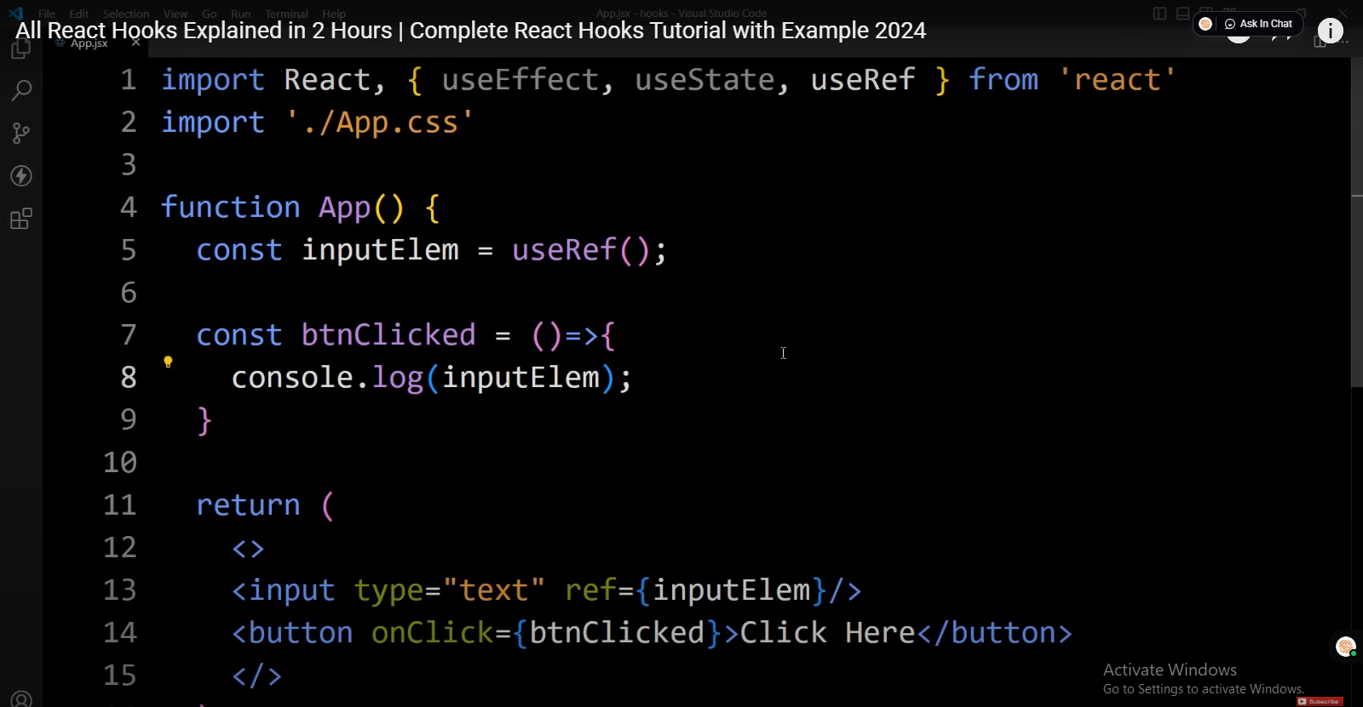

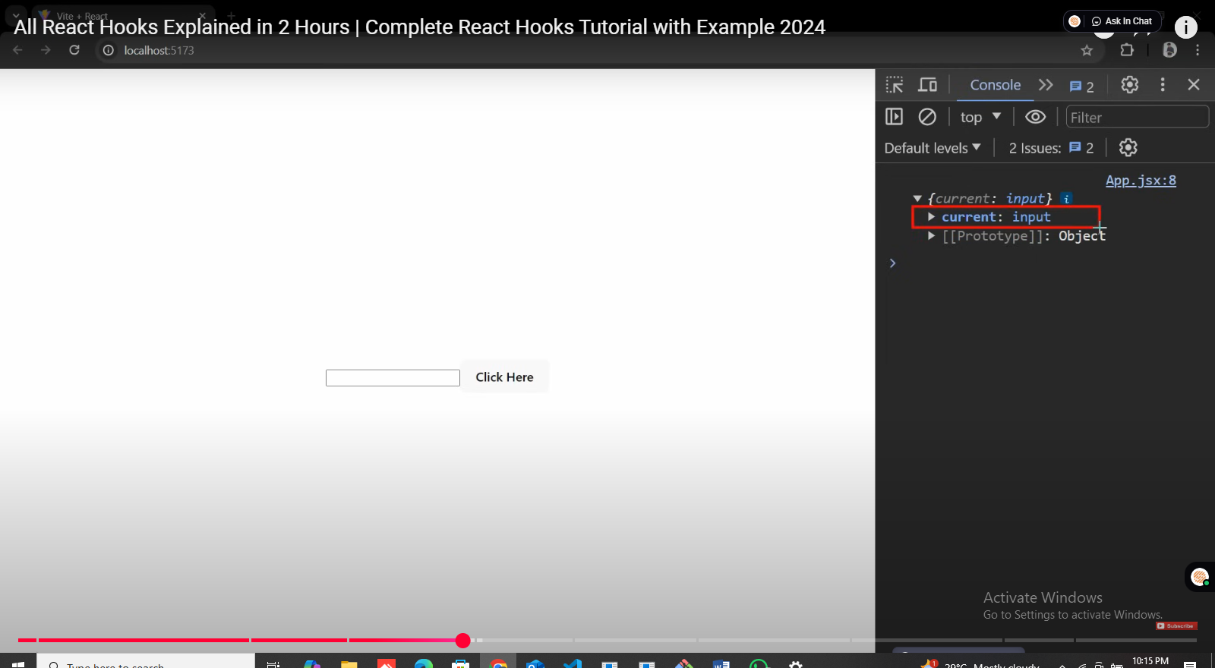

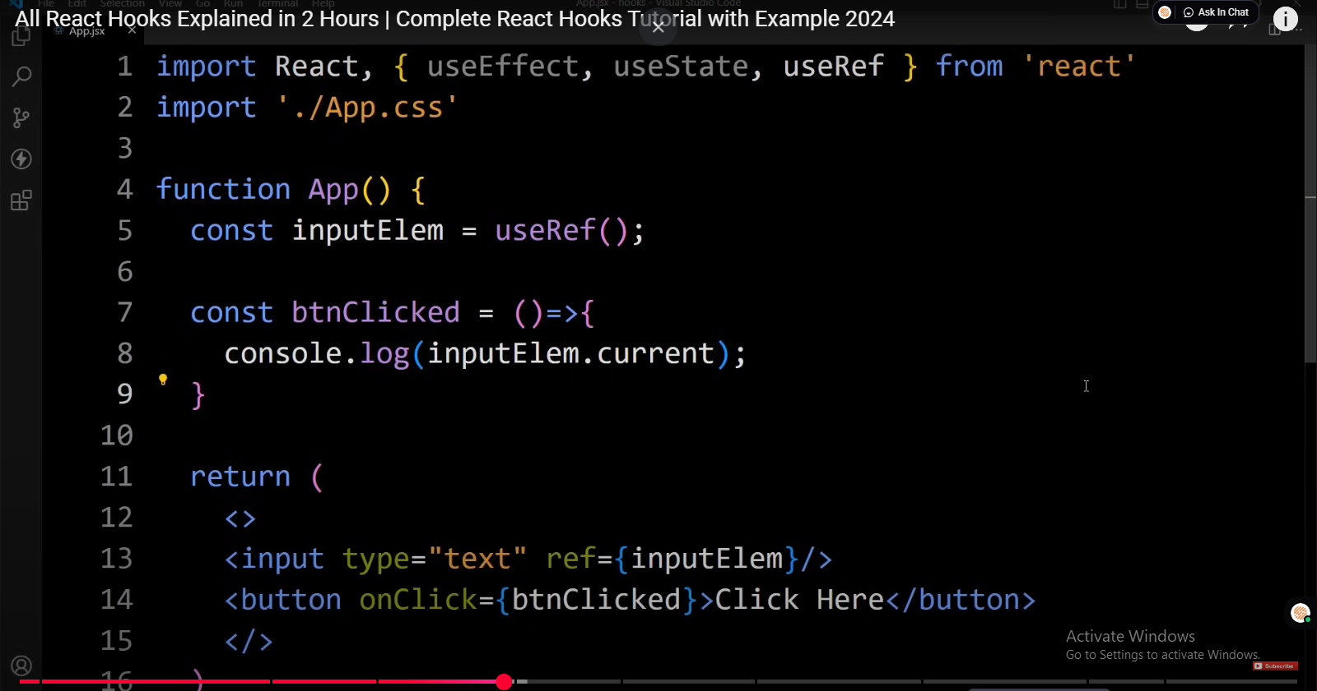

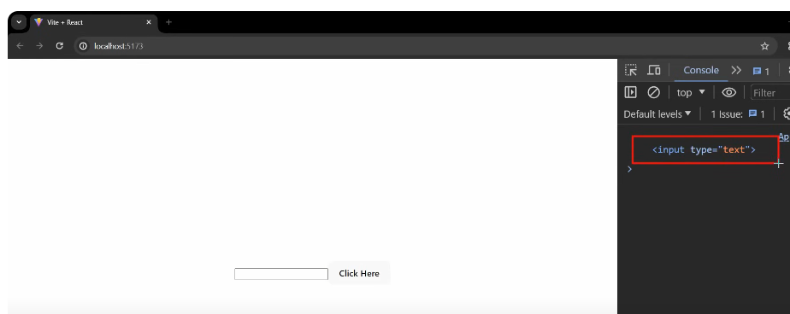

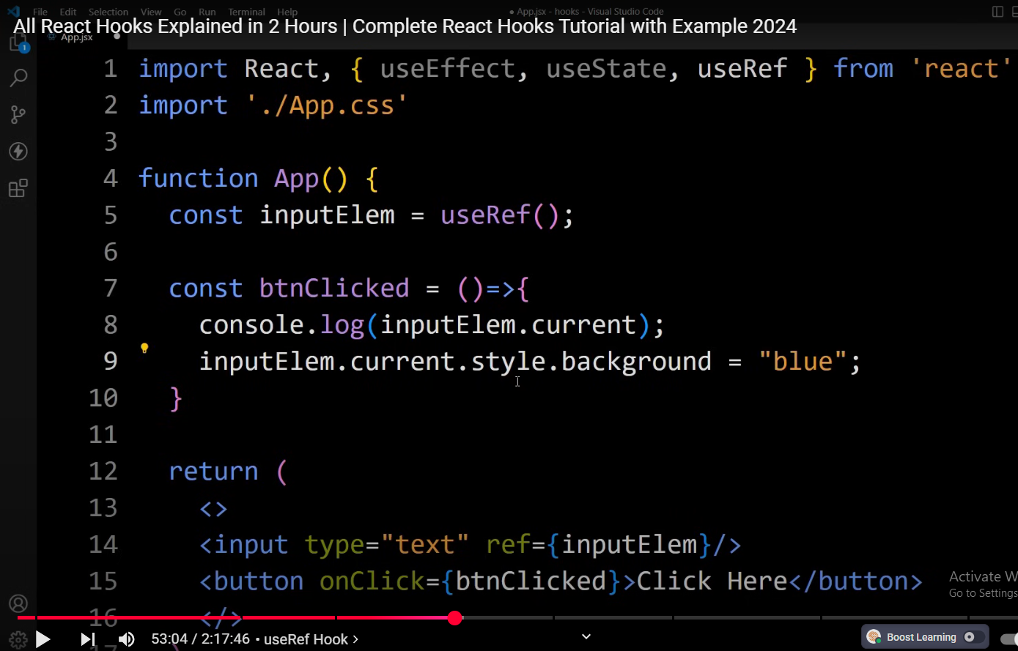

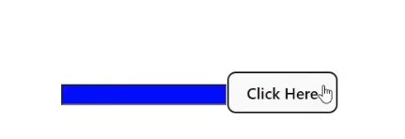

# UseMemo Hook

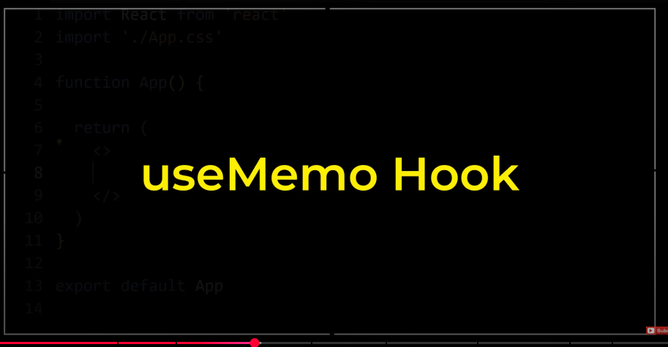

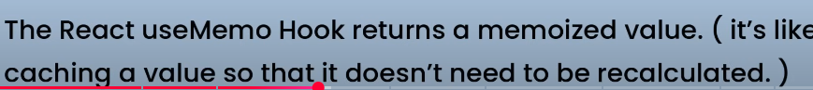







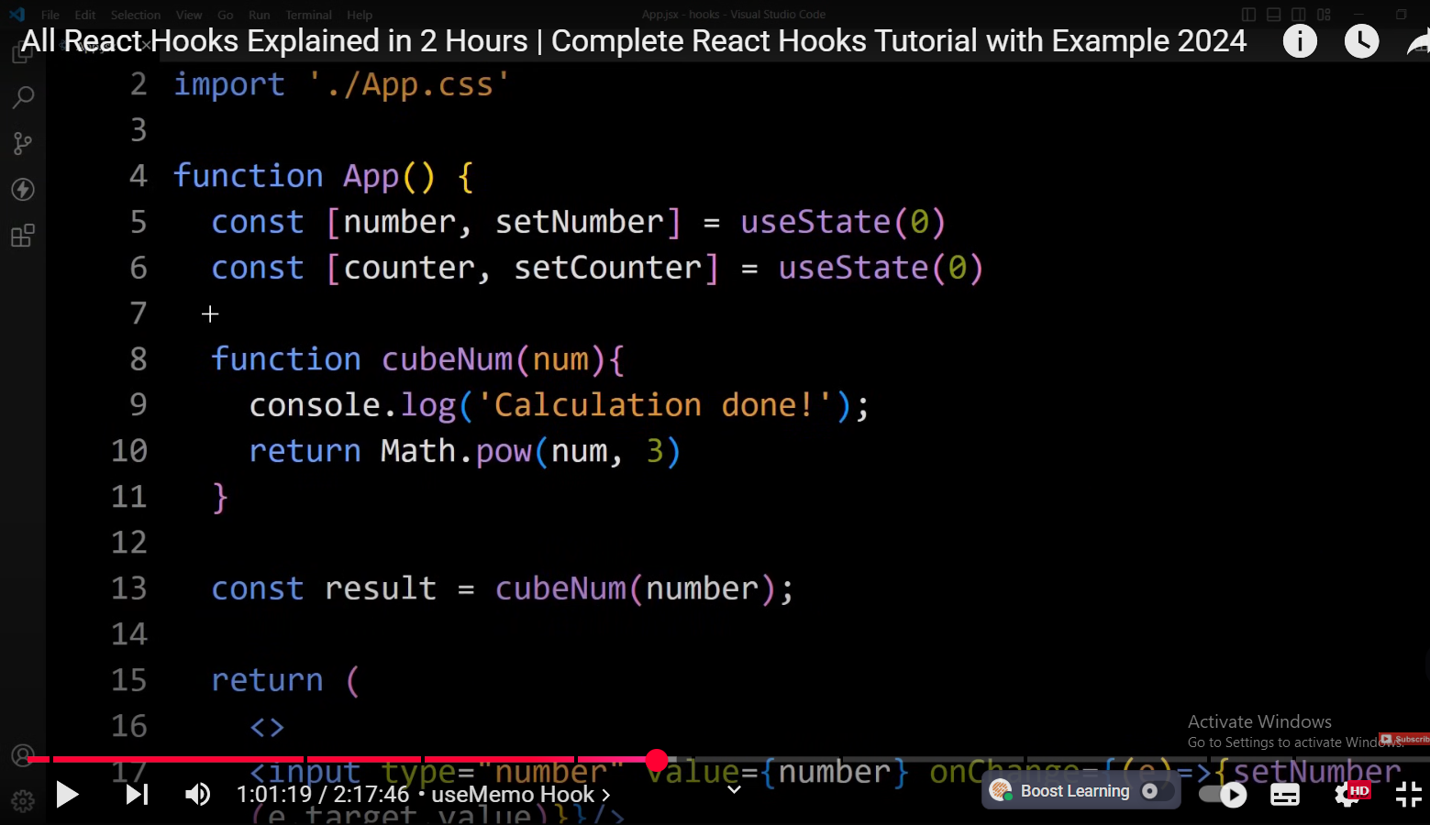

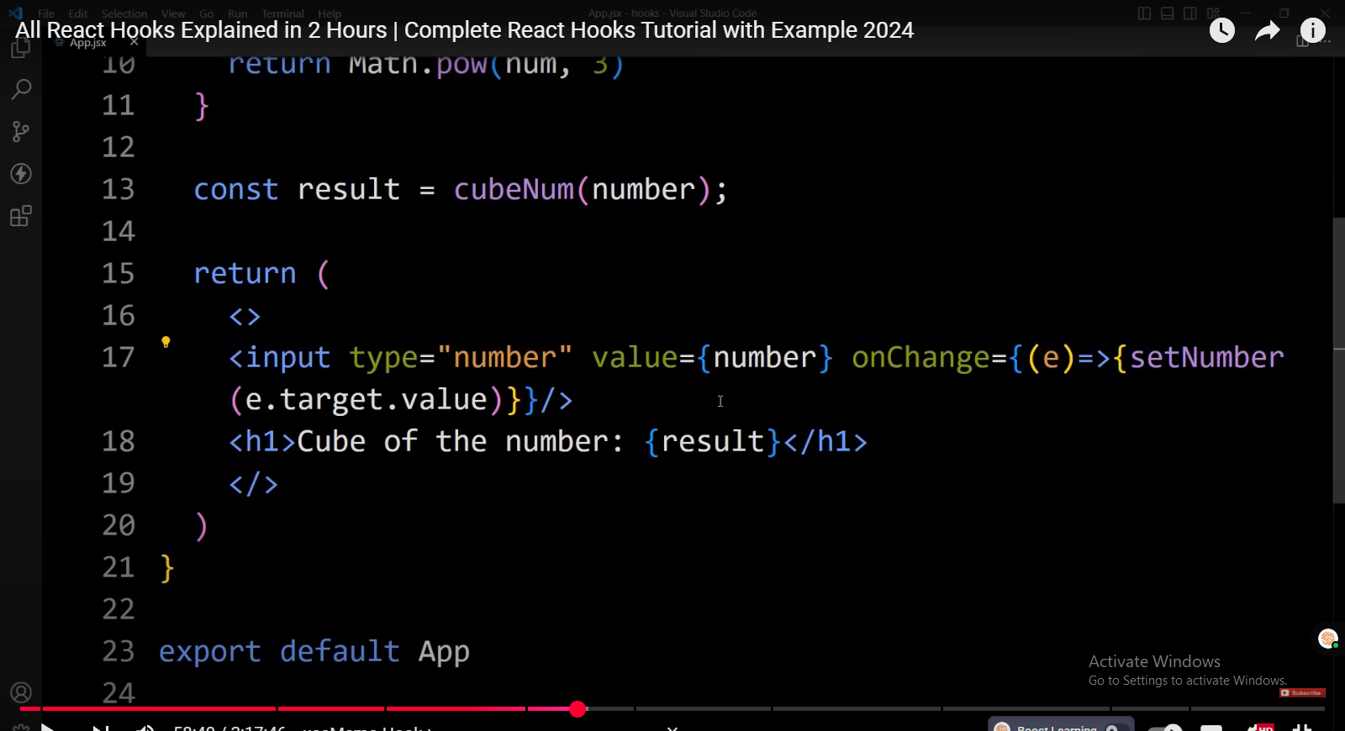

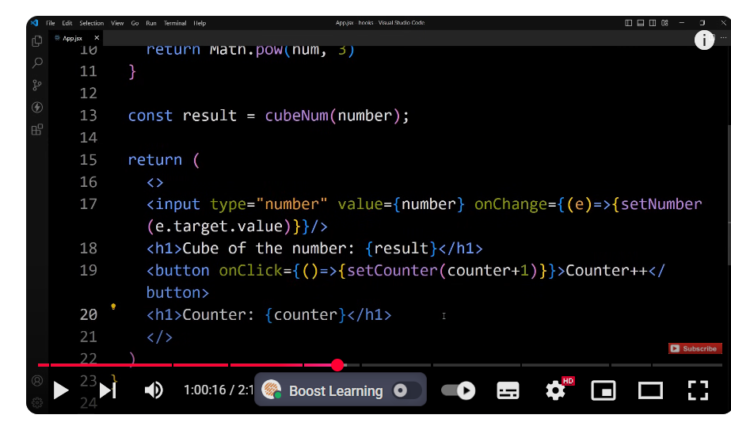

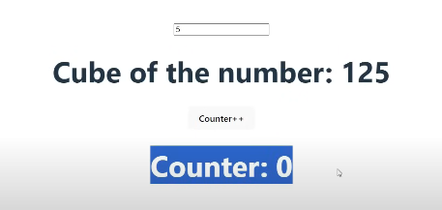

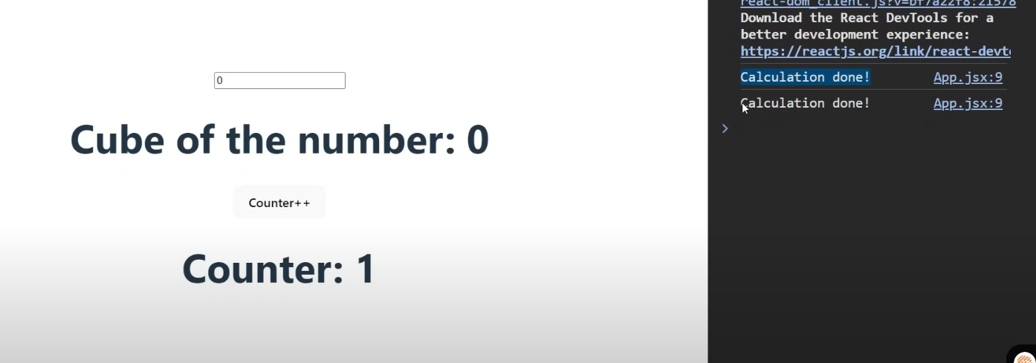



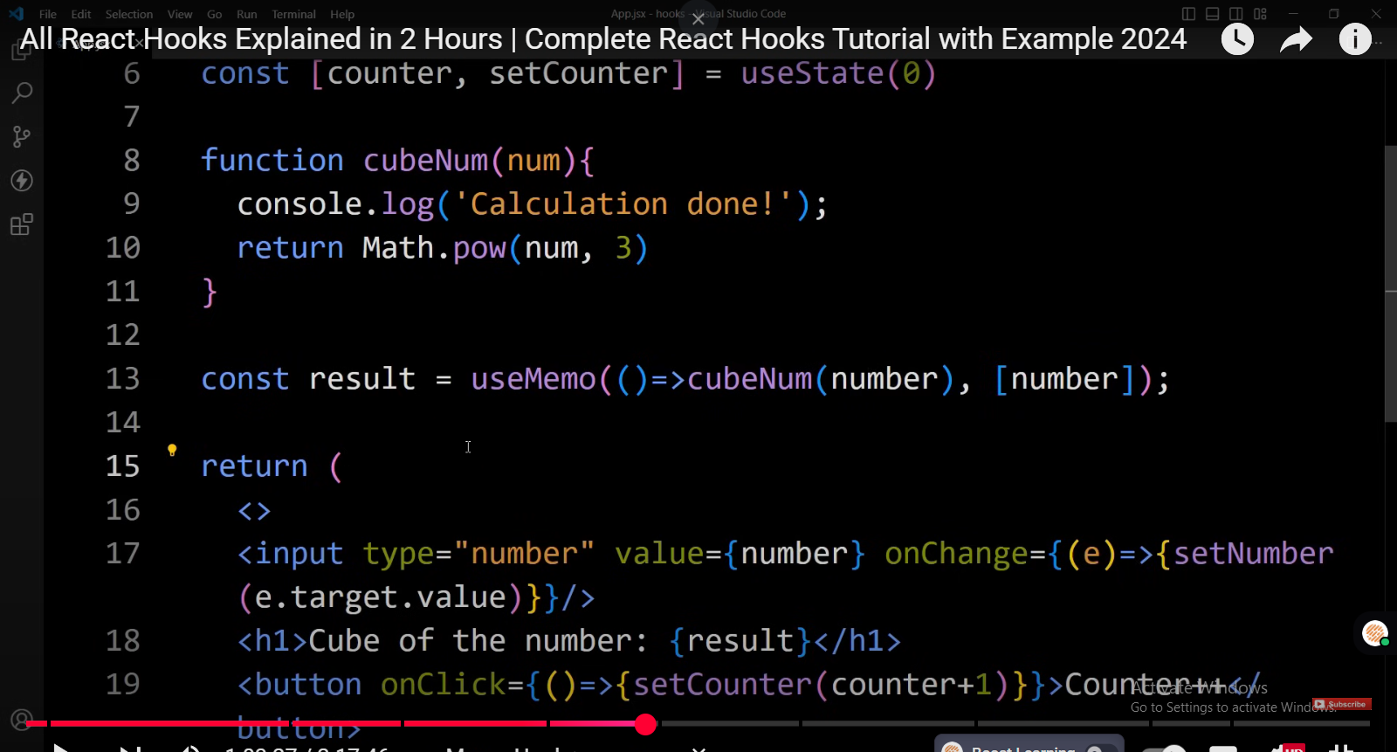

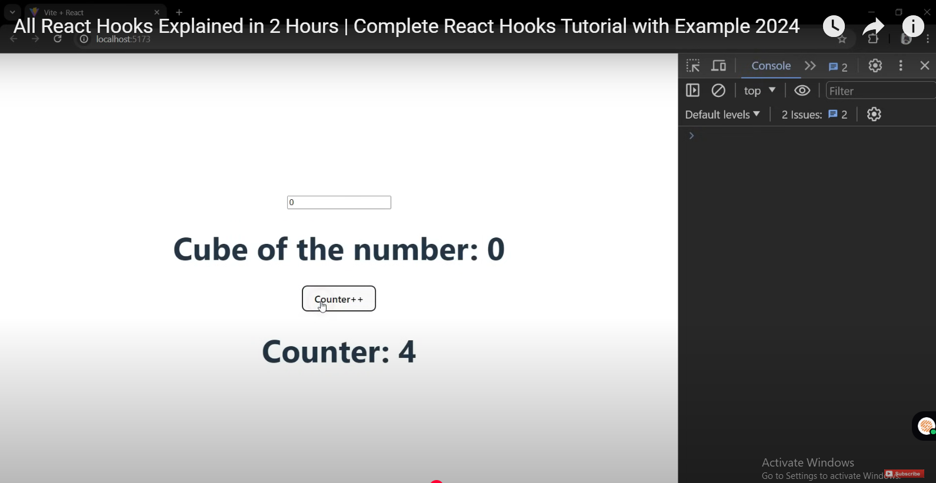

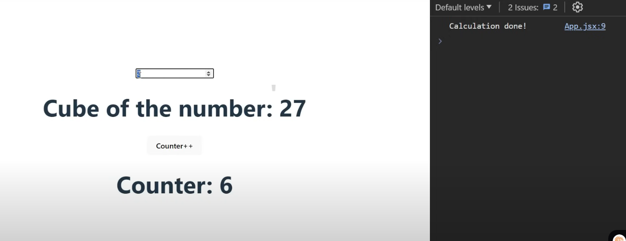

# useCallBack hook

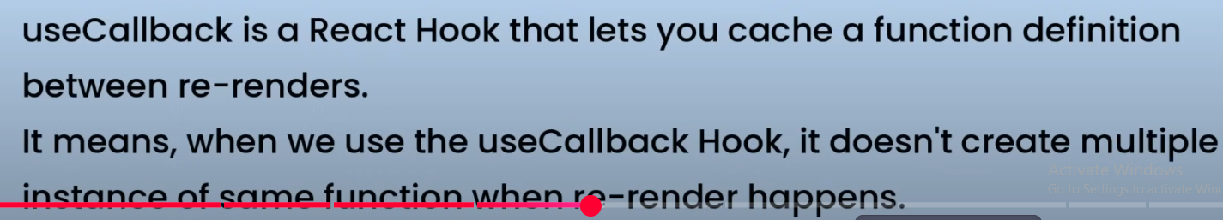



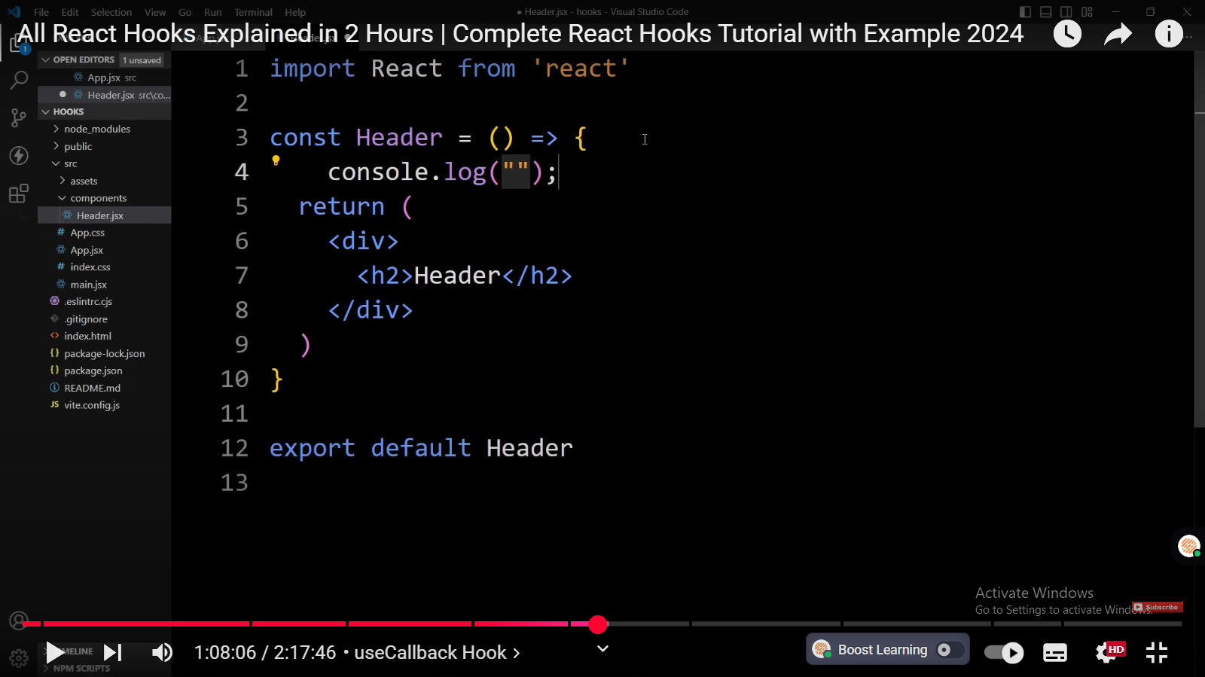

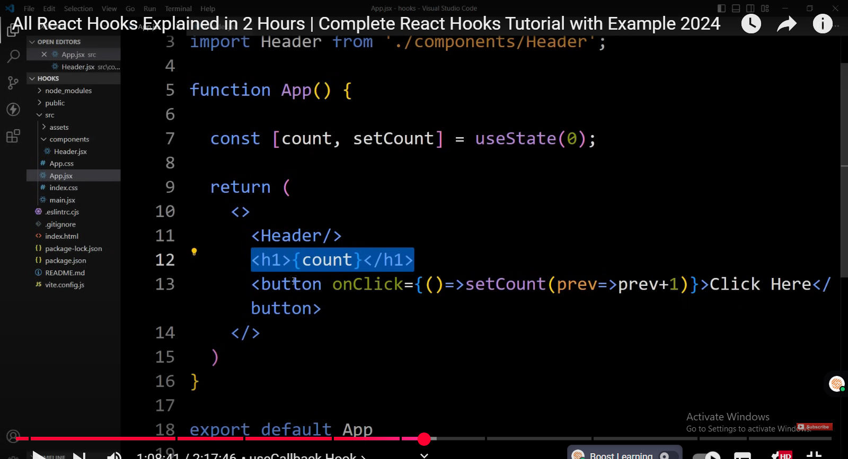

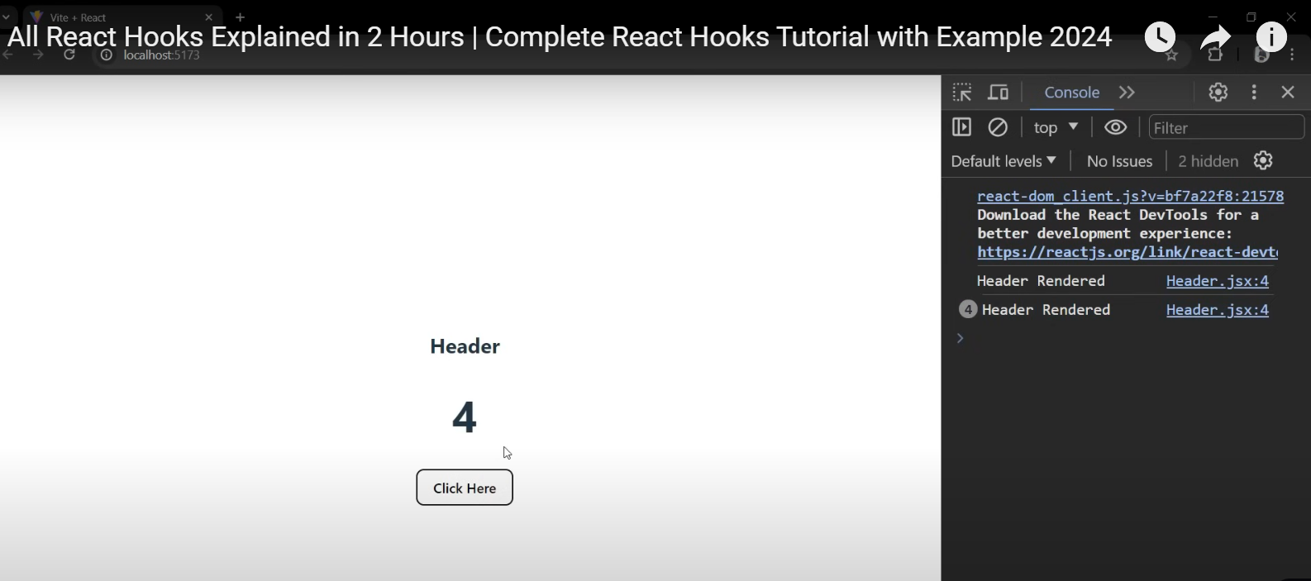

On updating counter, header component is rendered again and again , seein console. Although there is no update in header still itis rendering multiple times b/c counter update horaha aha aur app component rerender horaha aha aur q k header component bhi mount hua wa ha app k sath tou wo bhi rerender horaha ha

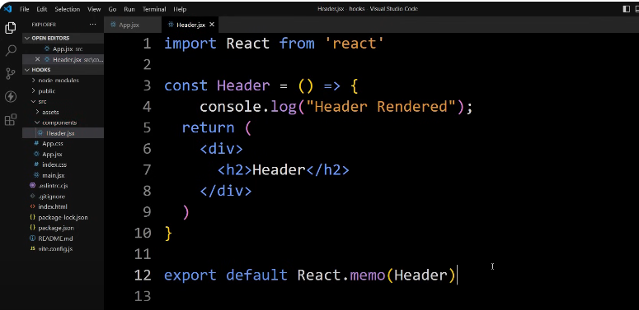

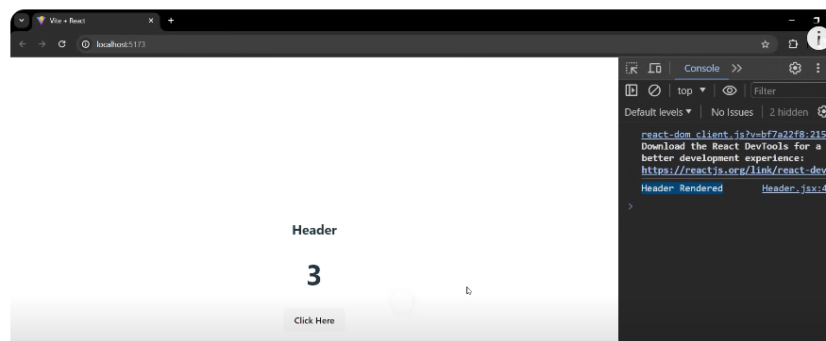

Header rendered only one time

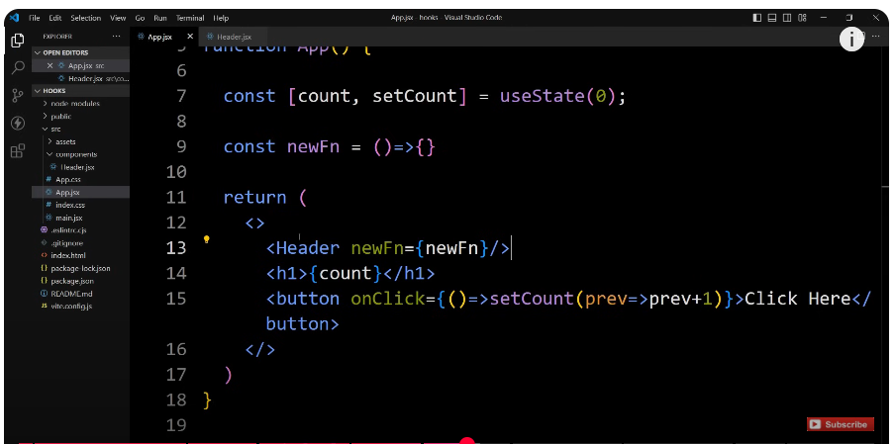

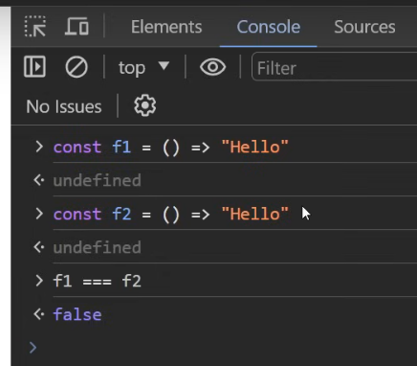

Referntial equality 🡪 above two func are not same b/c they are at different memory locations

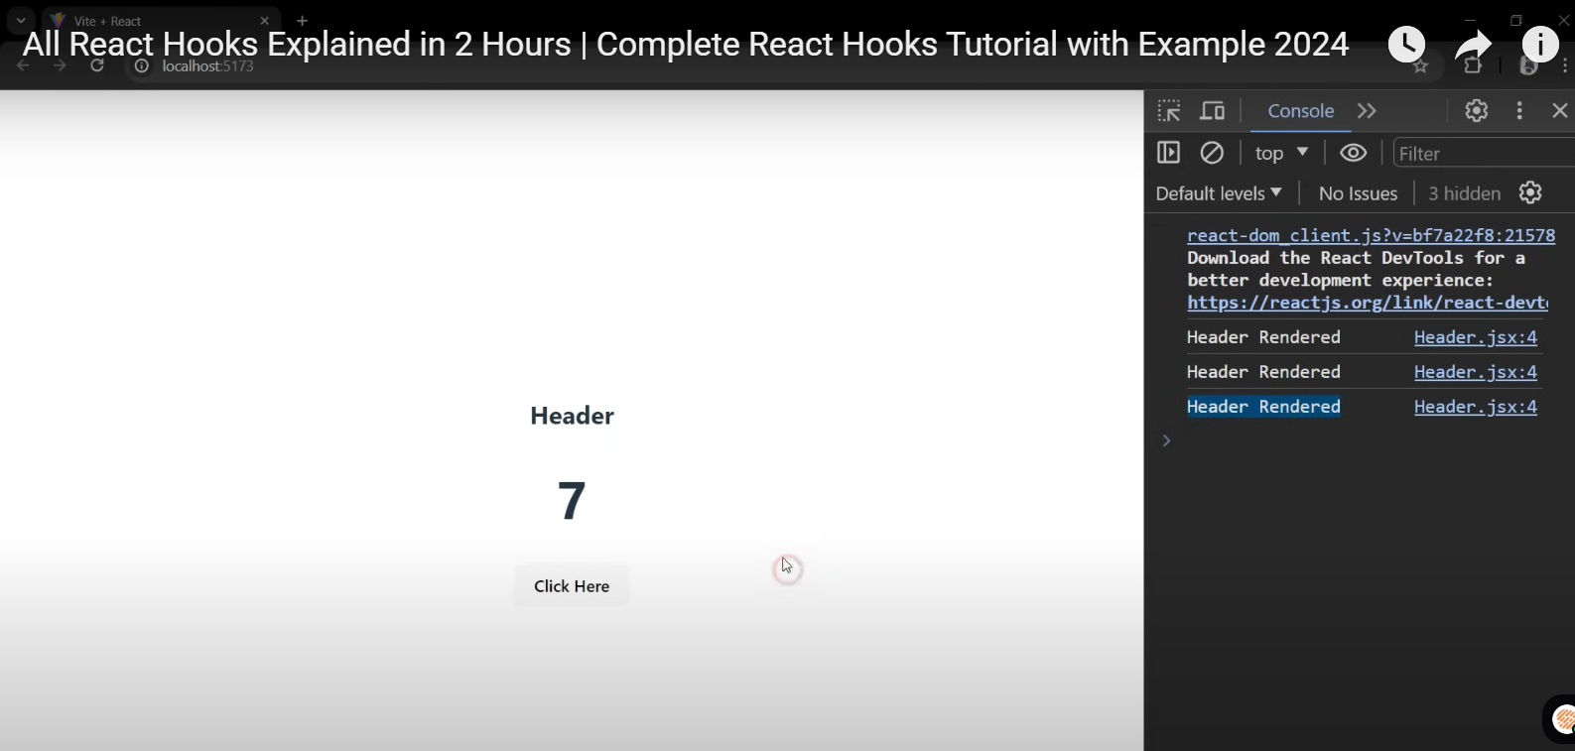

updating the counter it is again rendering the header component which is

1:12:34

not required because we are not changing anything in the header we are just passing the function and this is the

1:12:42

same function so why this is happening it is happening because of the

1:12:48

differential equality let me explain you the **referential equality**

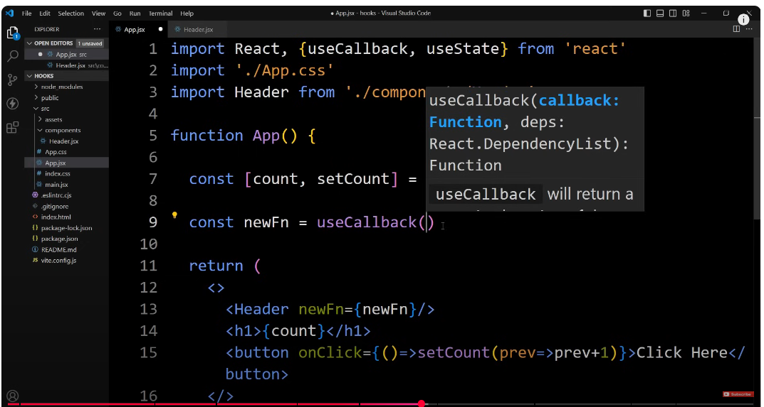



callback will not create another function it will use the catched

1:16:48

function whenever it will create this function first time and it will catch that function in the memory and whenever

1:16:55

the renders happen it will use that cached function so the function will be

1:17:00

same and when the function is same so this header props will be same there is

1:17:06

no changes in this header props so when the prop is not changing then headed

1:17:12

will not rendered again

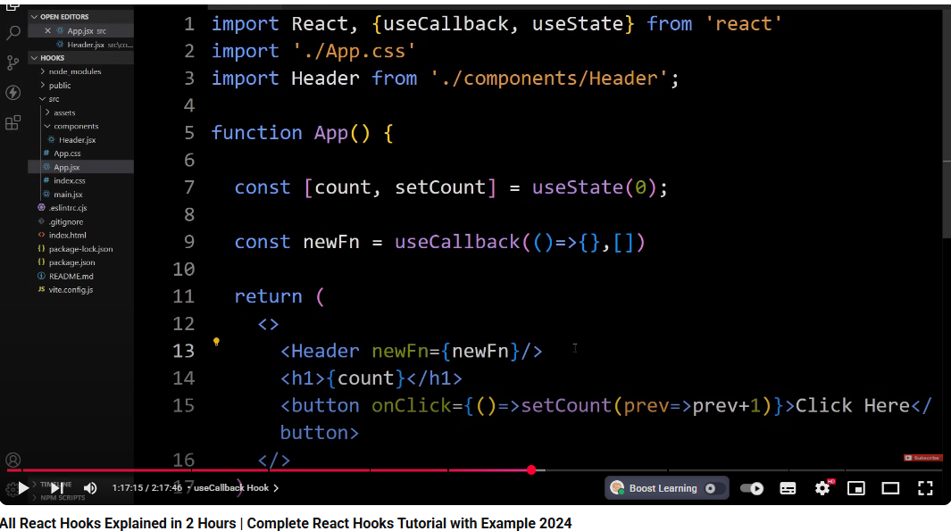

Use call back will prevent this header component to unnecessary re-render

This is how we use call back function to cache the fuction

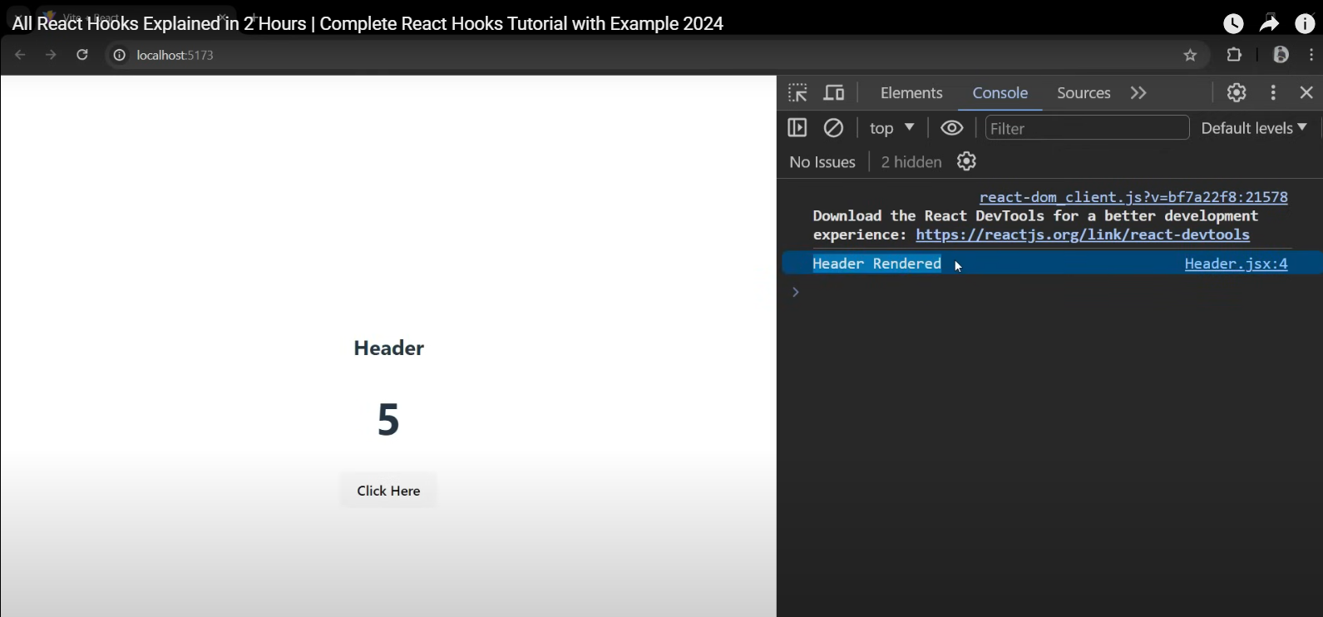

Heder reder only once although the count state is changing and app component is rerendered

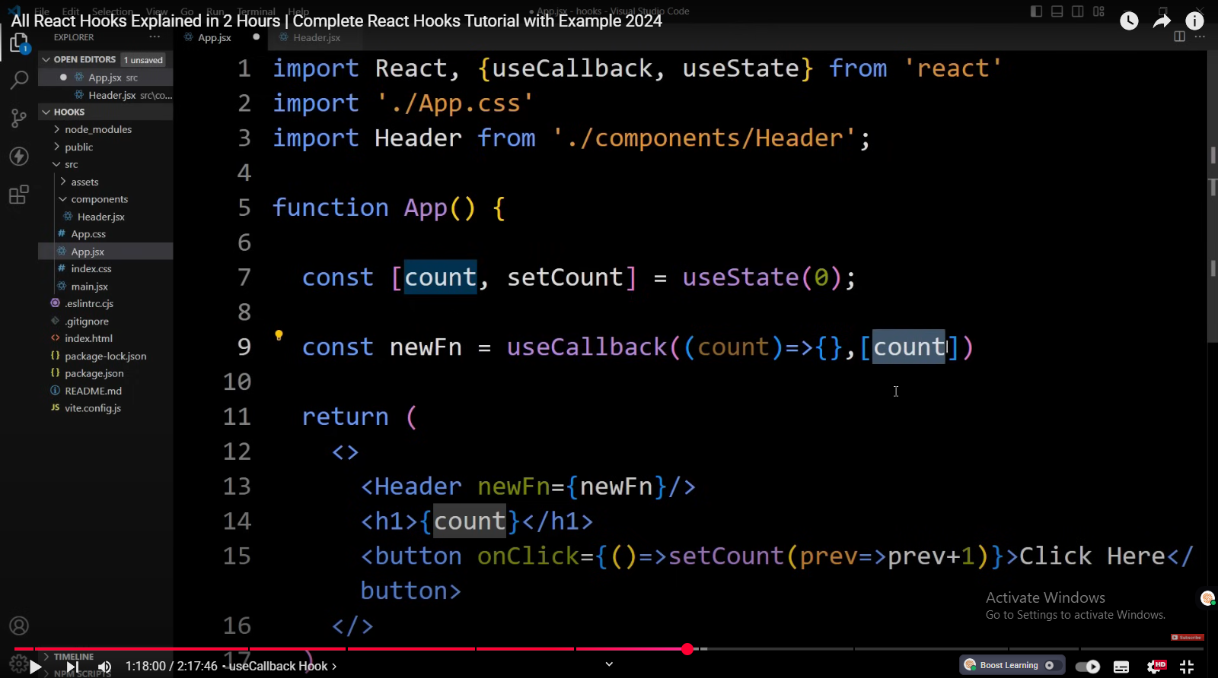

Whenever count chnages it will create a new function and new func will pass i header component

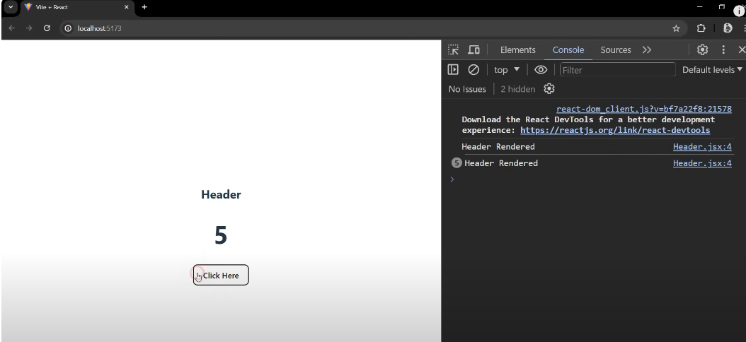

The rerendering is happening as count changes.

 whenever this dependency is changing it is creating

1:18:51

new function and when we remove this dependency it will not create a new

1:18:57

function it will use the cached function so the function will be same and this

# useContext Hook

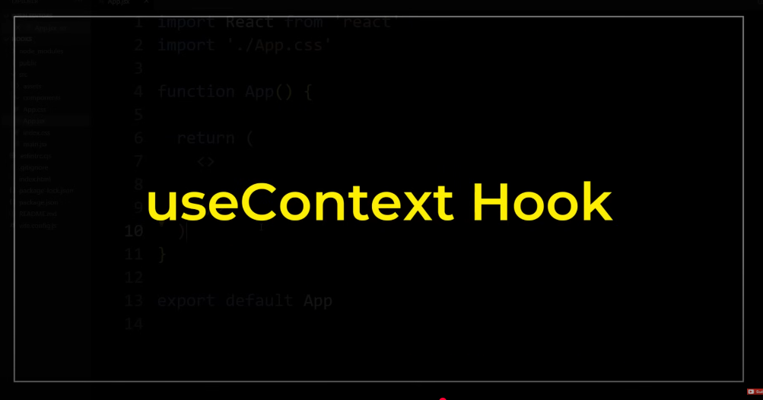





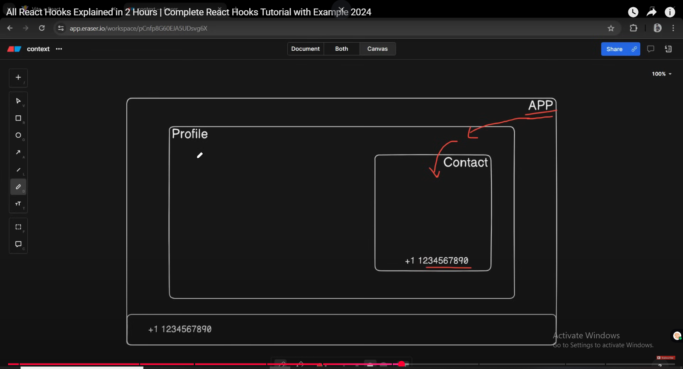

when we

1:21:47

have more nested components it will be very difficult to manage the data and we

1:21:52

have to pass the data through to each component level to solve this problem

1:21:58

use context was introduced that allow us to create global data and we can access

1:22:04

these data from any component without passing it through props at every component

1:22:10

level we can use the use context hook in three simple steps first one is creating

1:22:17

the context the second step is providing the context and the third step is

1:22:23

consuming the context

## step 1: Create Context

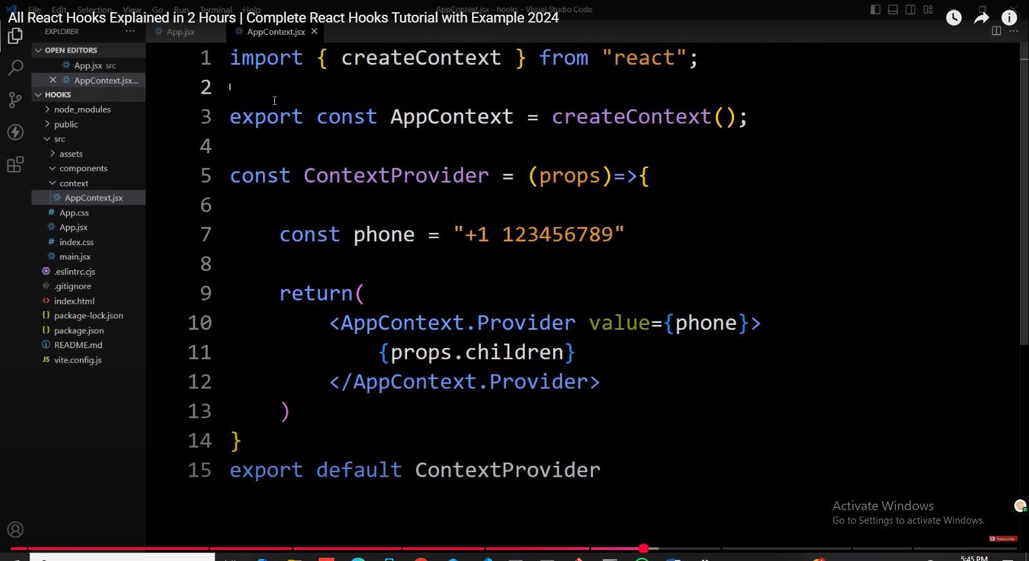

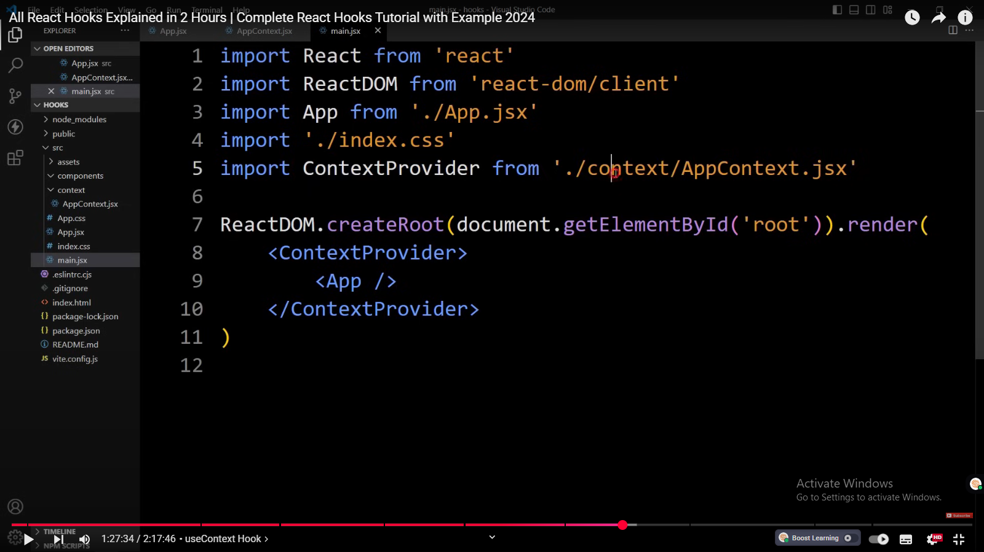

We have added support of context in react app

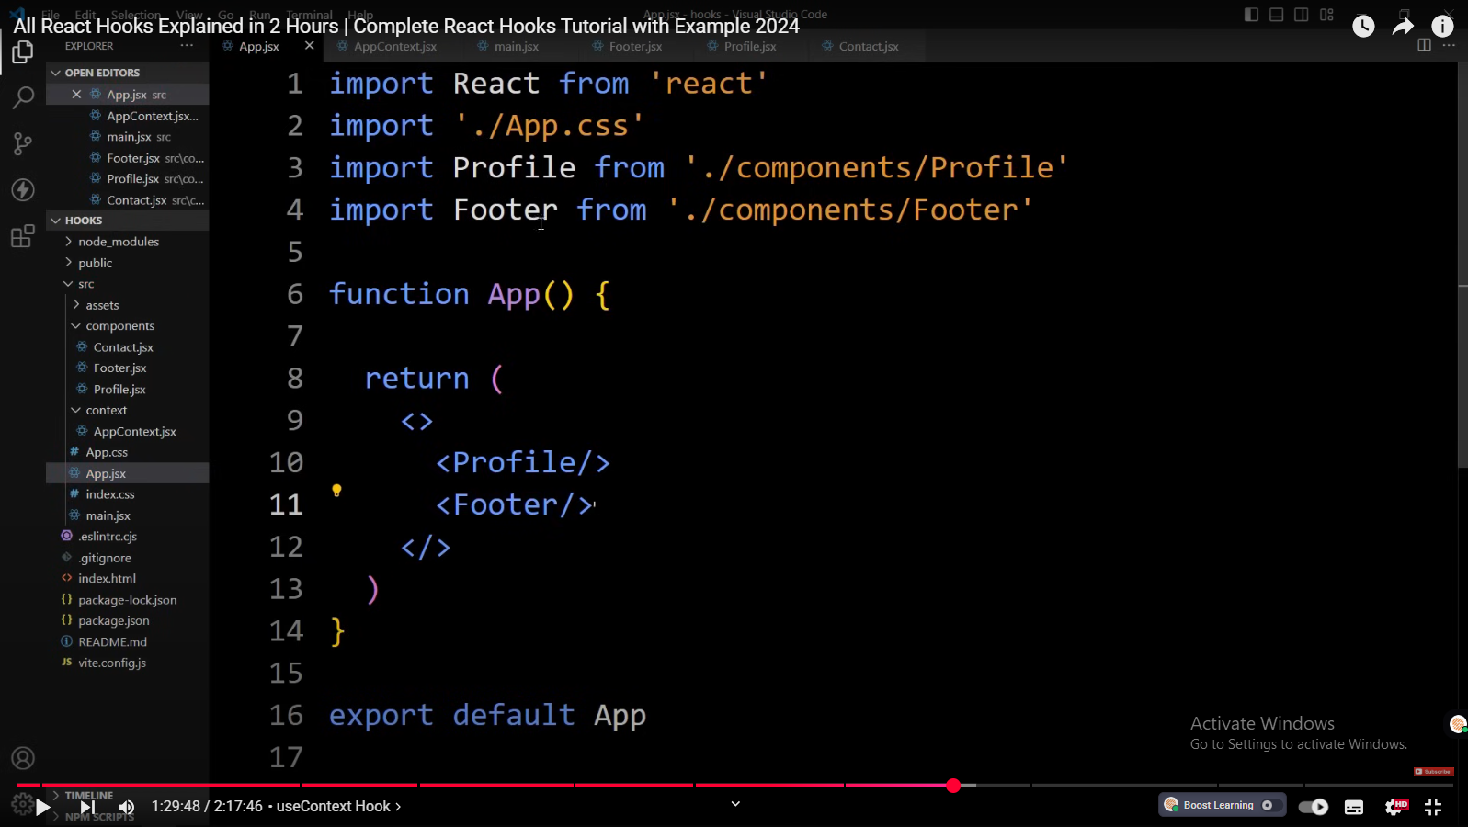

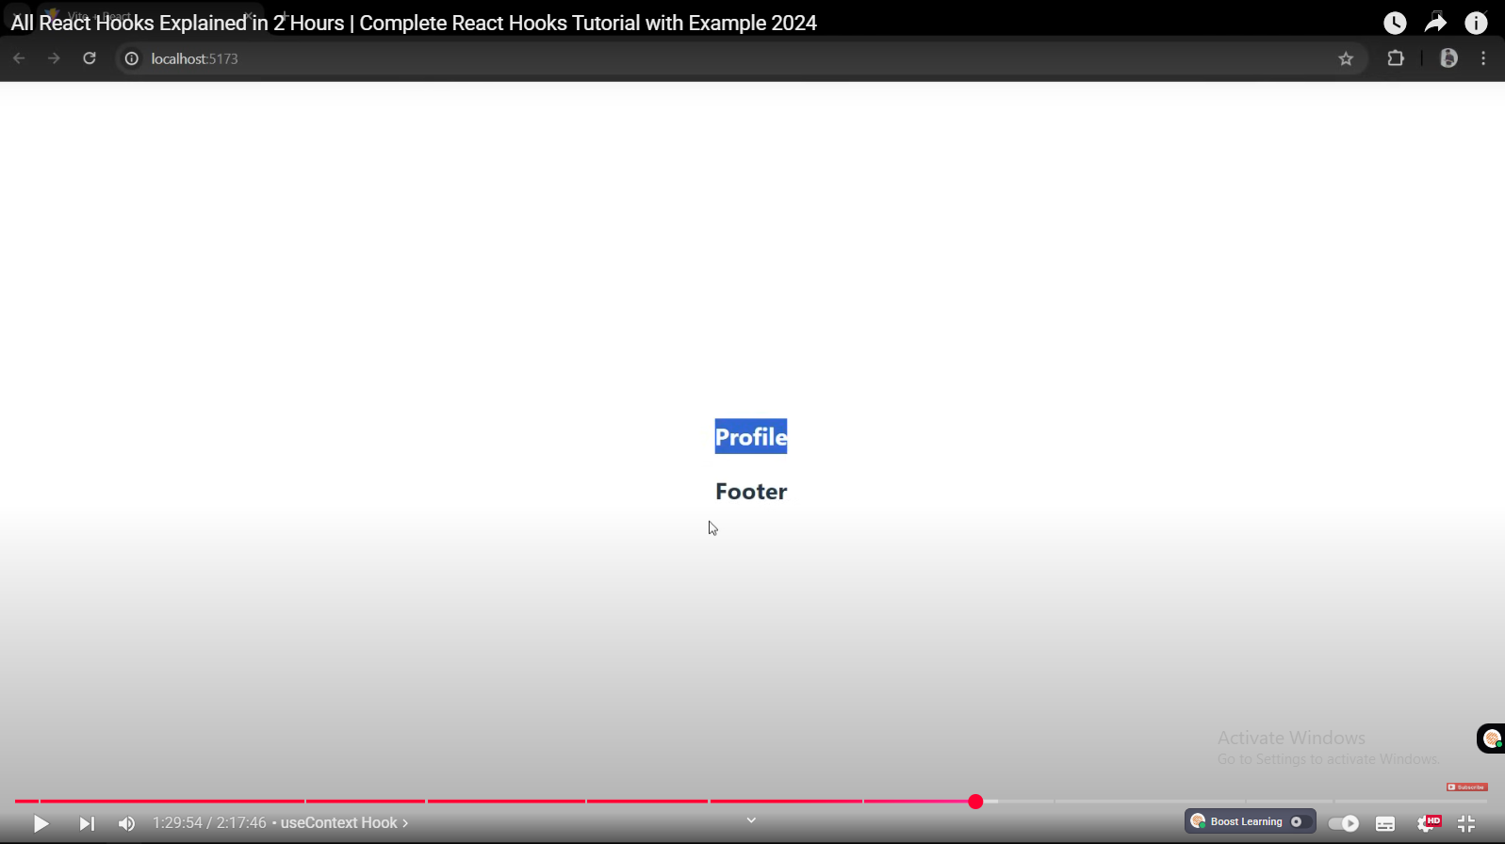

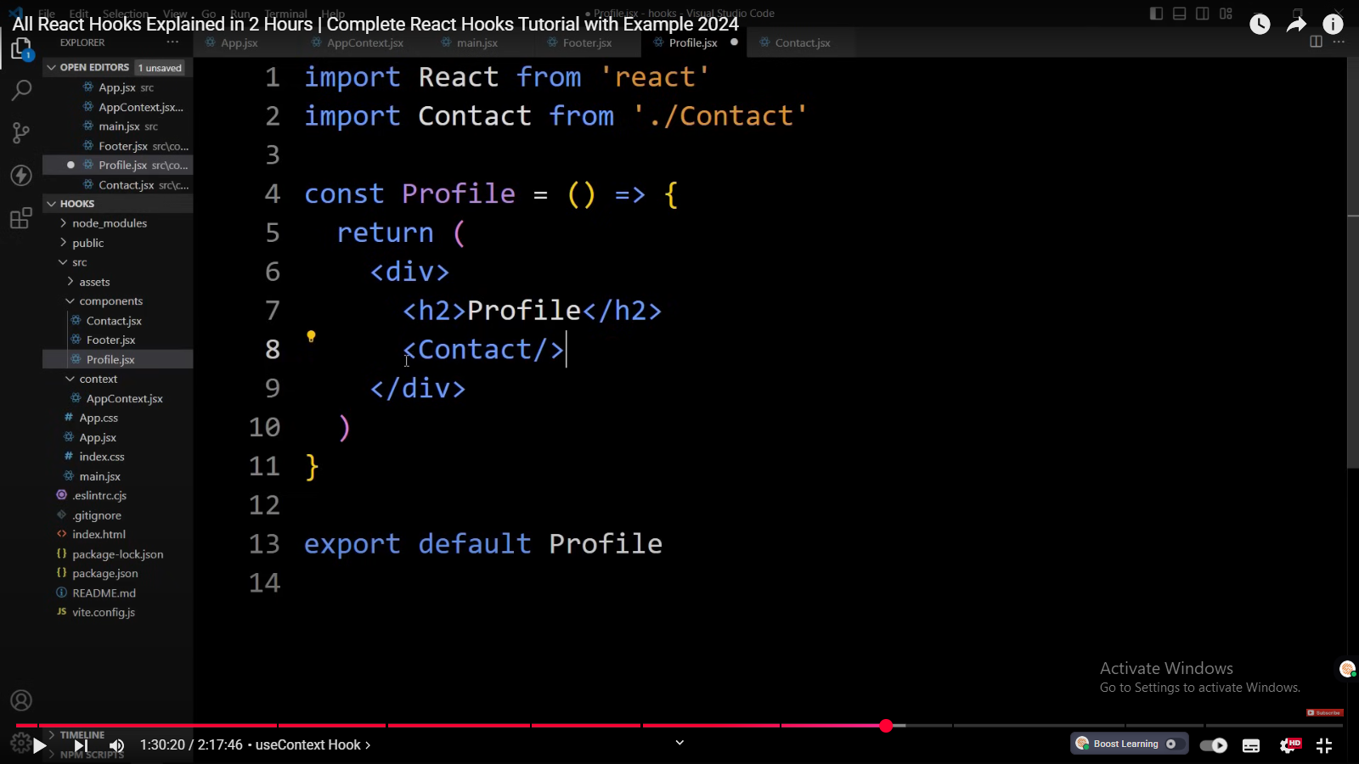

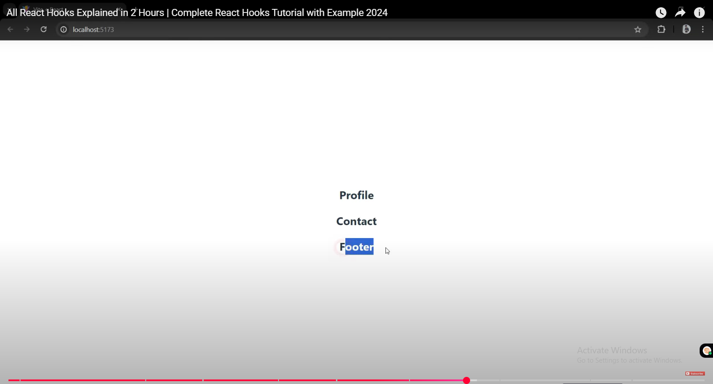

## Step 3: Consuming context

For creating context : createContext ,

To consume Context: useContext

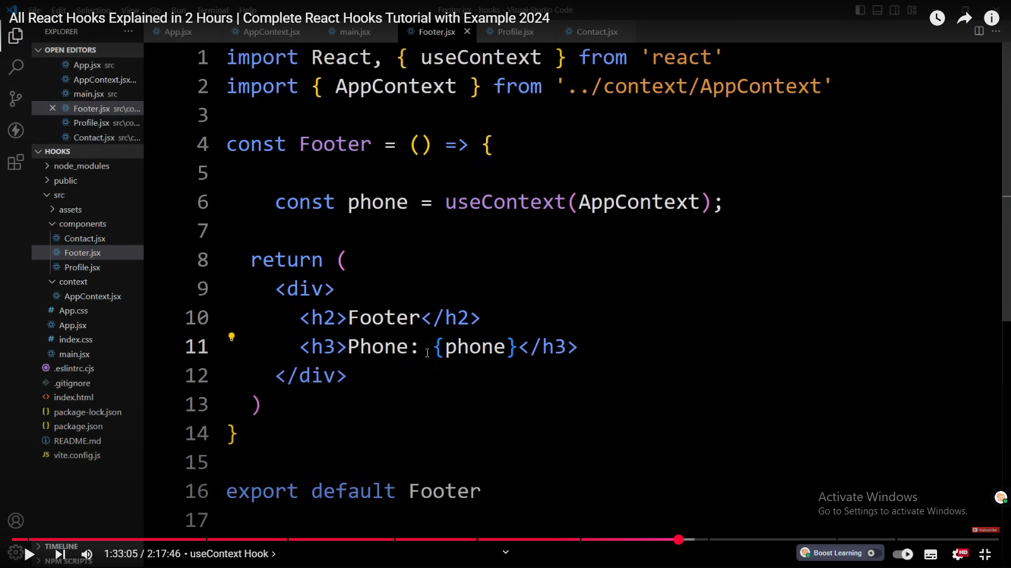

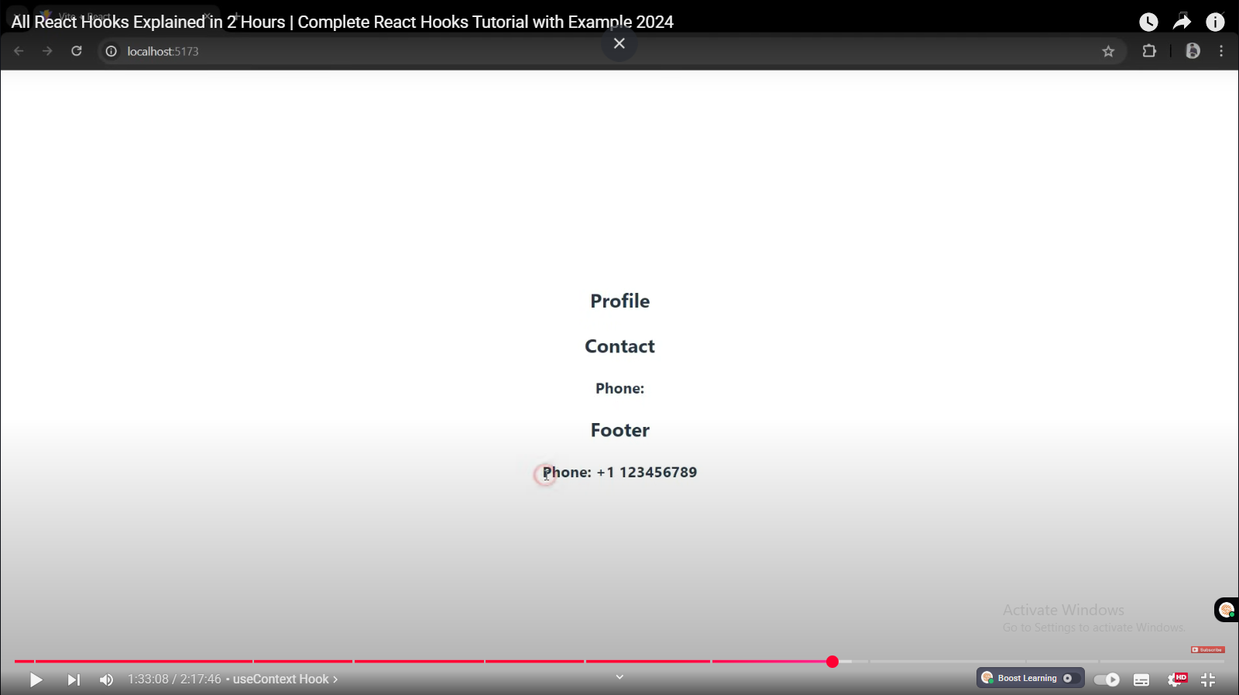

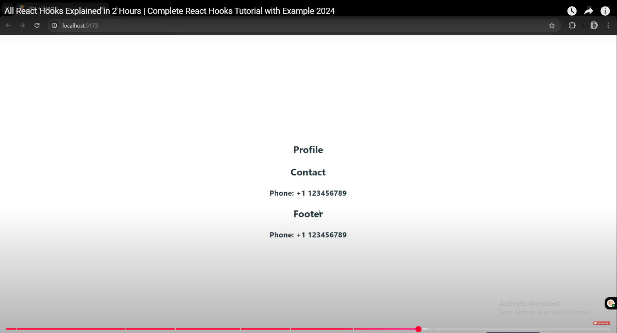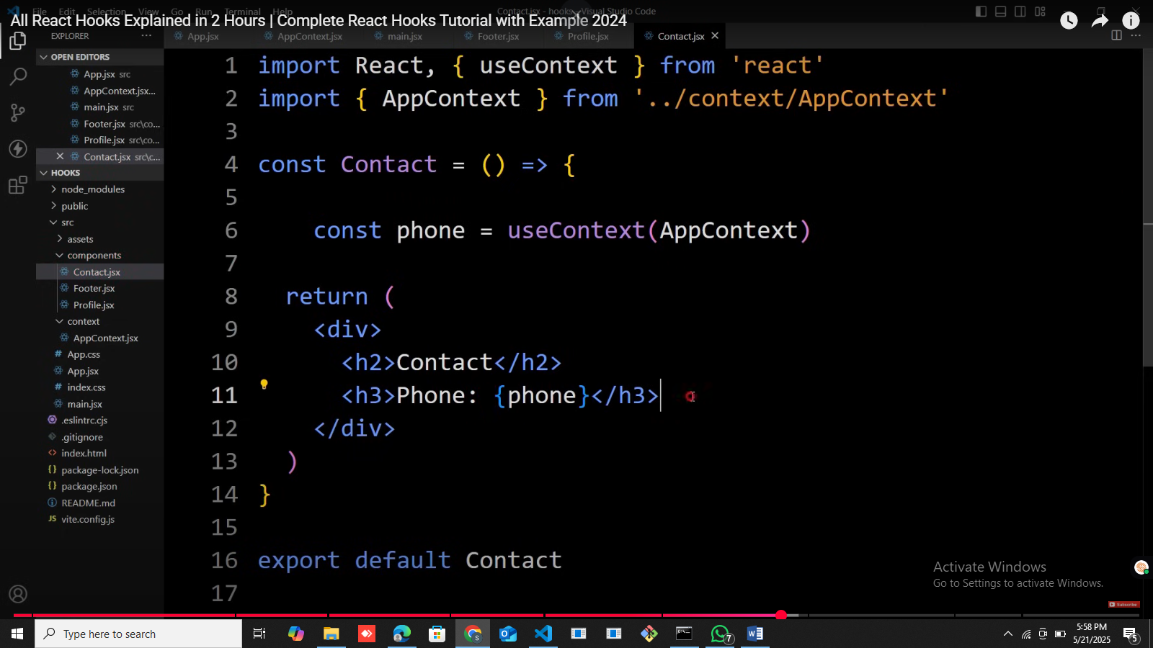

## If we need to pass multiple properties:

We will pass it through object value me jo {{}}

## 

Conaume krte waqt bhi cury brackets

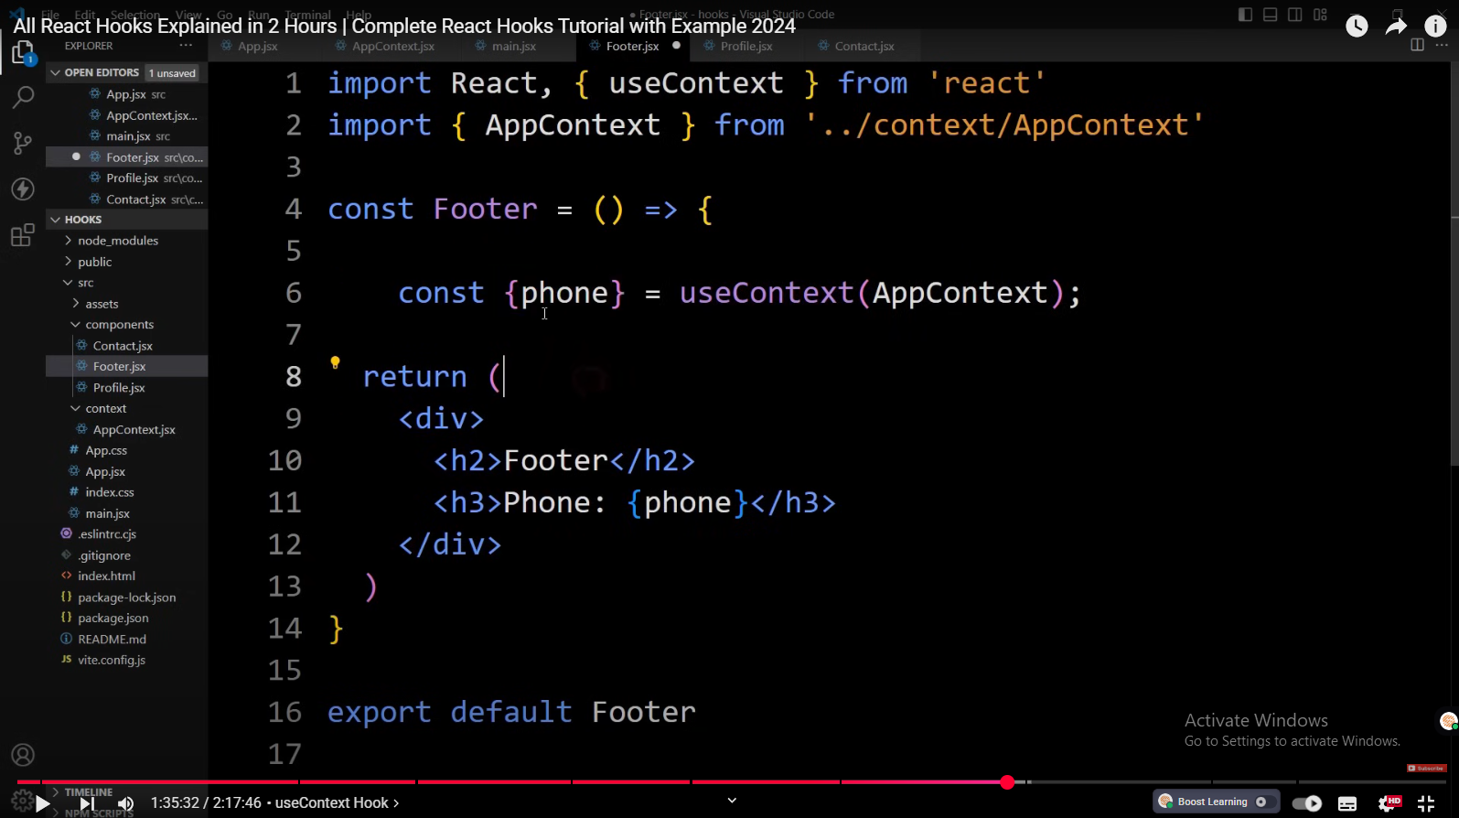

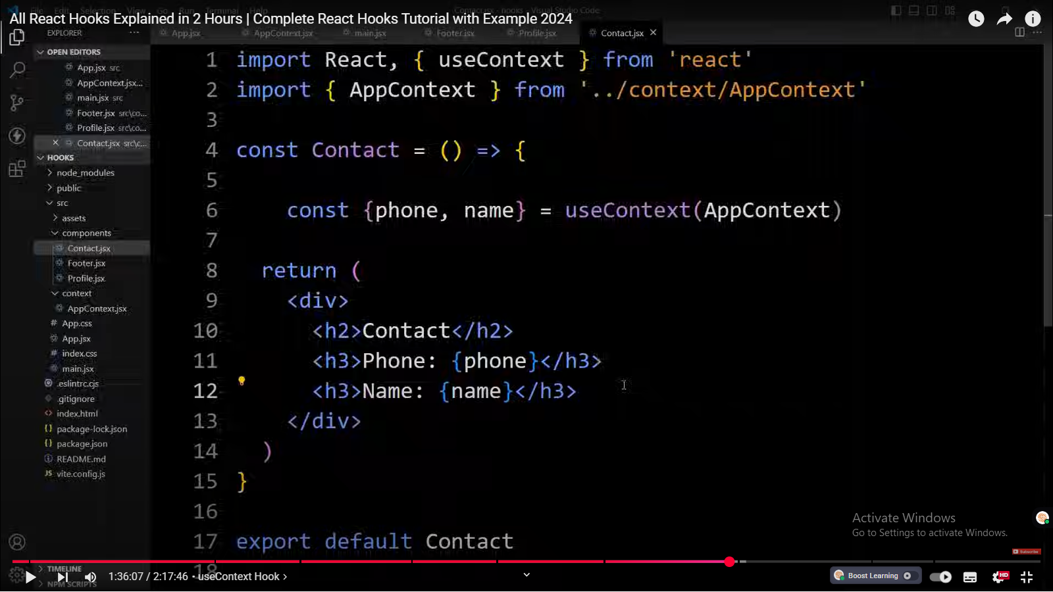

Objetcs , arrays, functions anything can be passed using context

you can pass the variables you can pass the function and you can pass

1:36:22

the state variables or any data so this is how we can use the use context hook

1:36:29

to manage global data the context API can be used to share any type of data

1:36:36

including objects functions and arrays this makes it a flexible solution for

1:36:42

variety of Estate Management needs most common use of context API is to share

1:36:50

the current theme of your application with all components or to share the authenticated

1:36:57

user with all of our components in our application or to share the result of an

1:37:04

API call with all of our components in our application that will reduce the

1:37:10

number of API calls so this was all about the use context hook in

# useReducer Hook

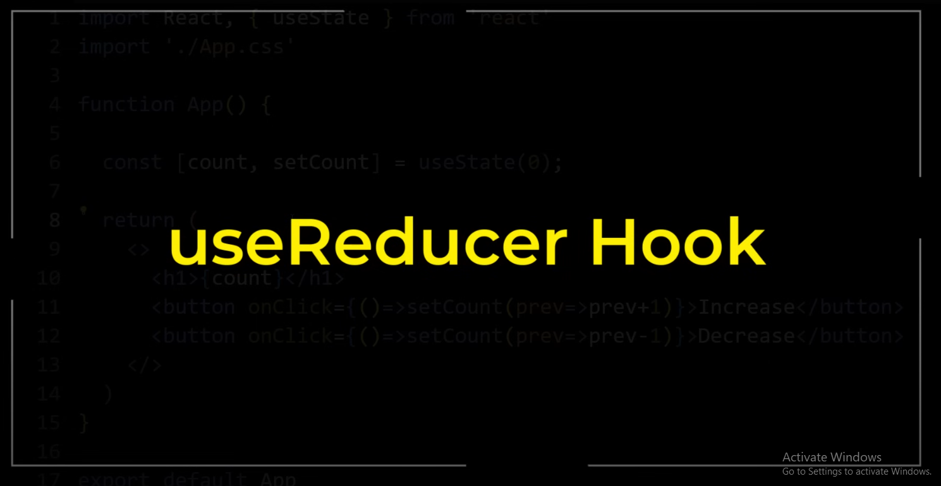



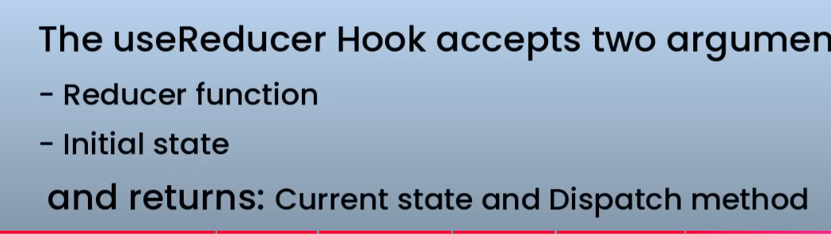



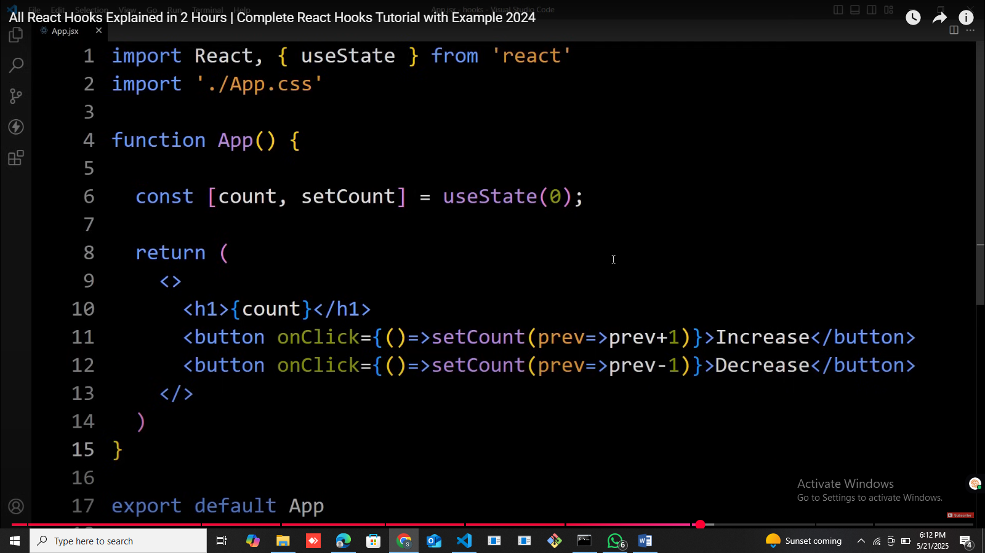

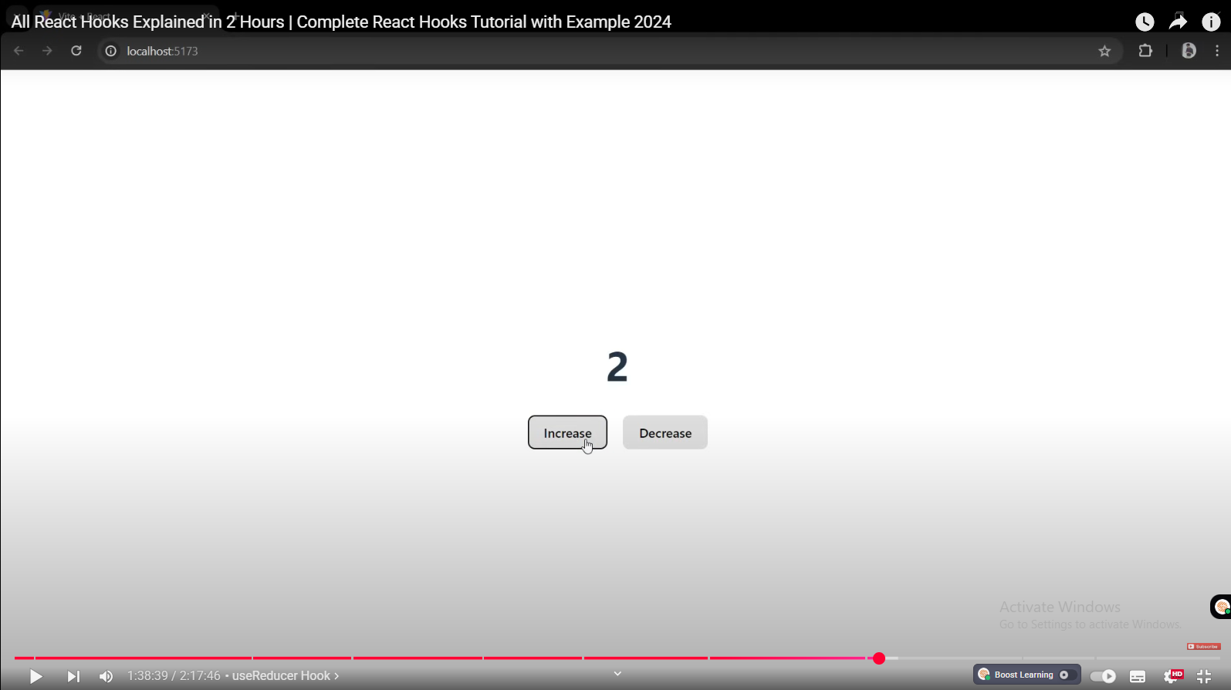

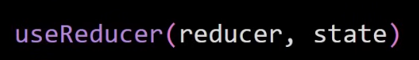

 use reducer returns one aray

1:40:34

same as use a state hook

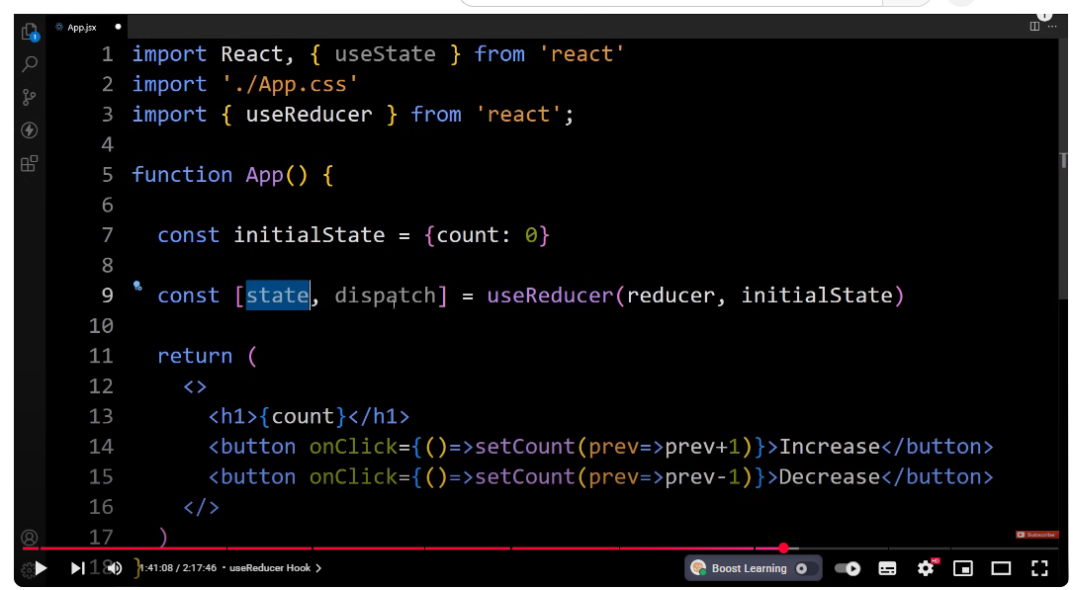

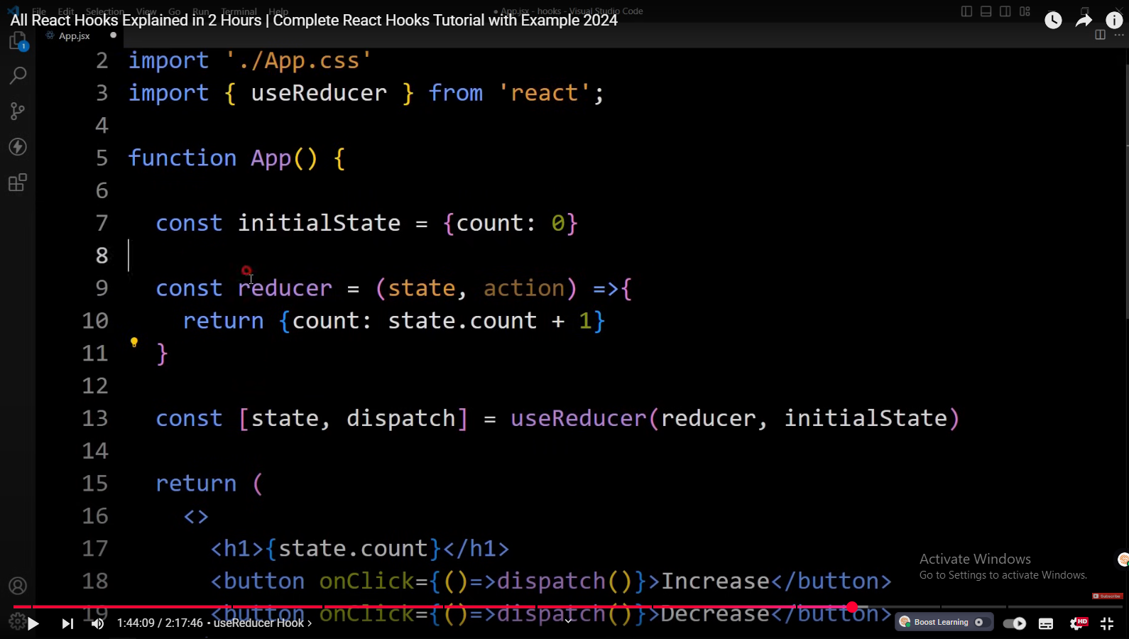

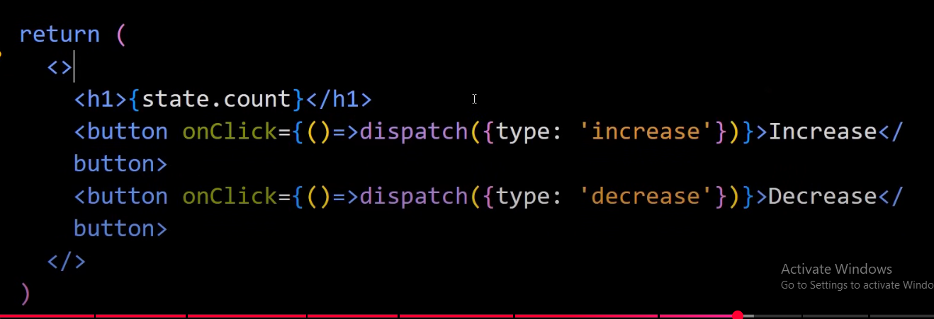

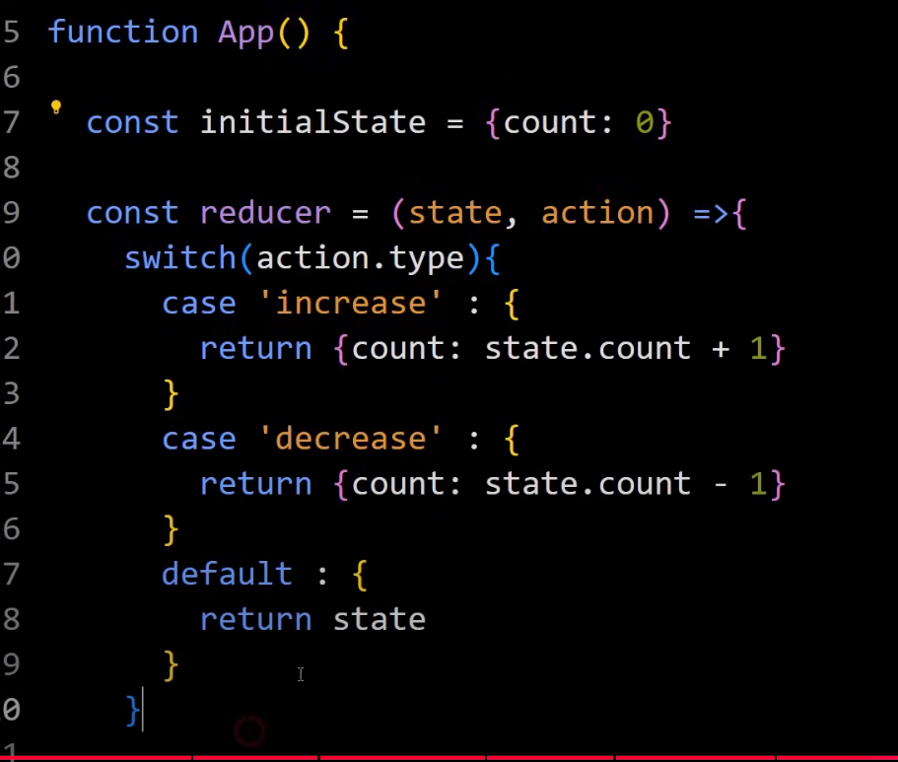

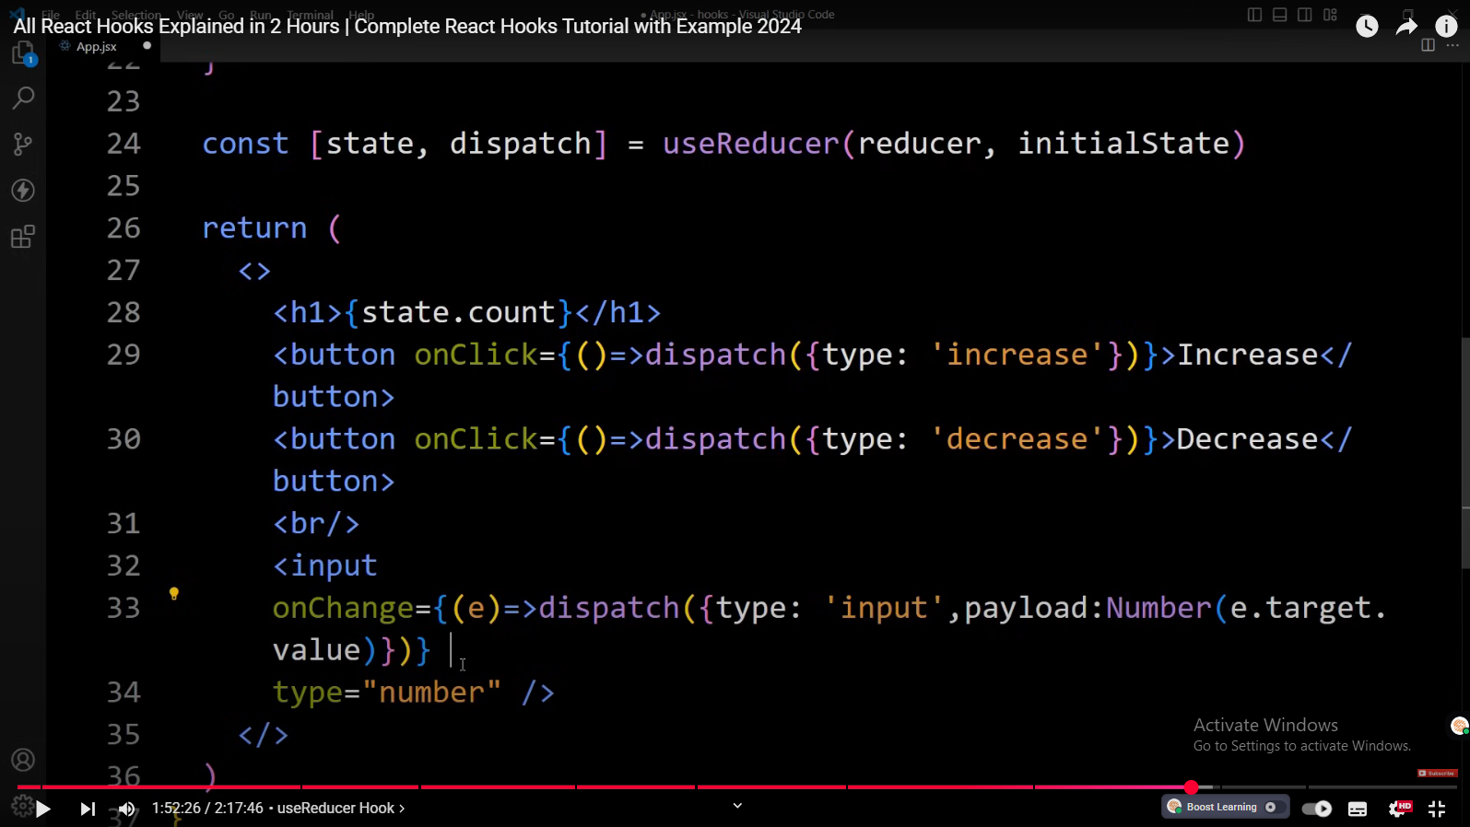

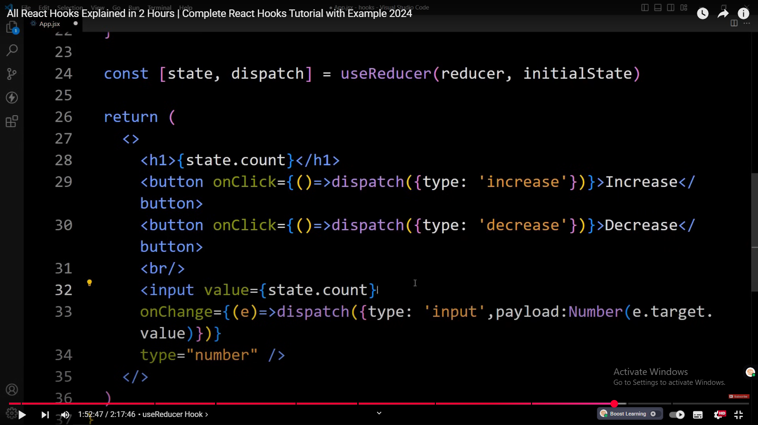

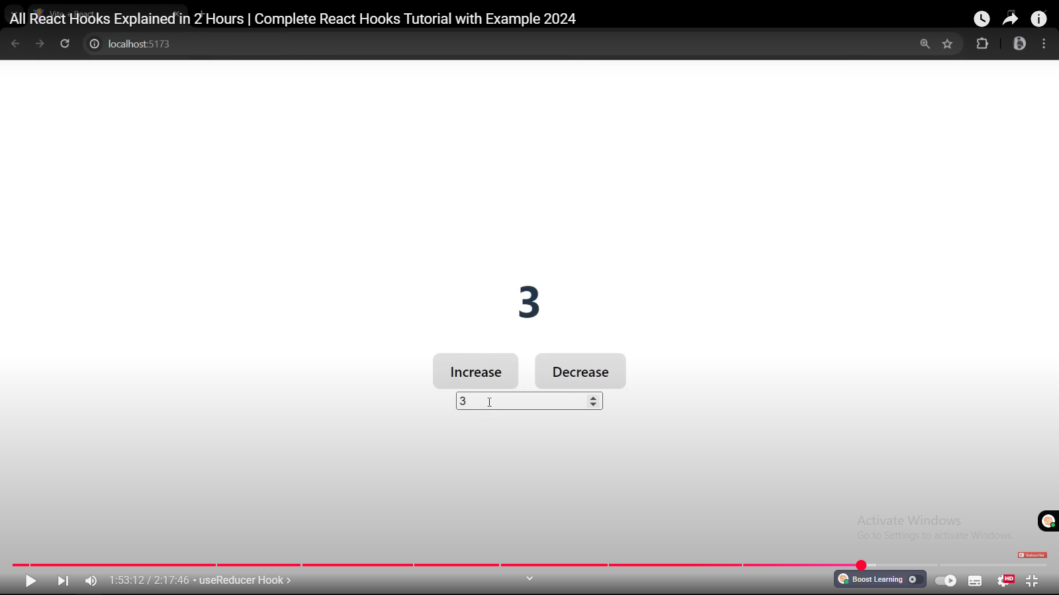

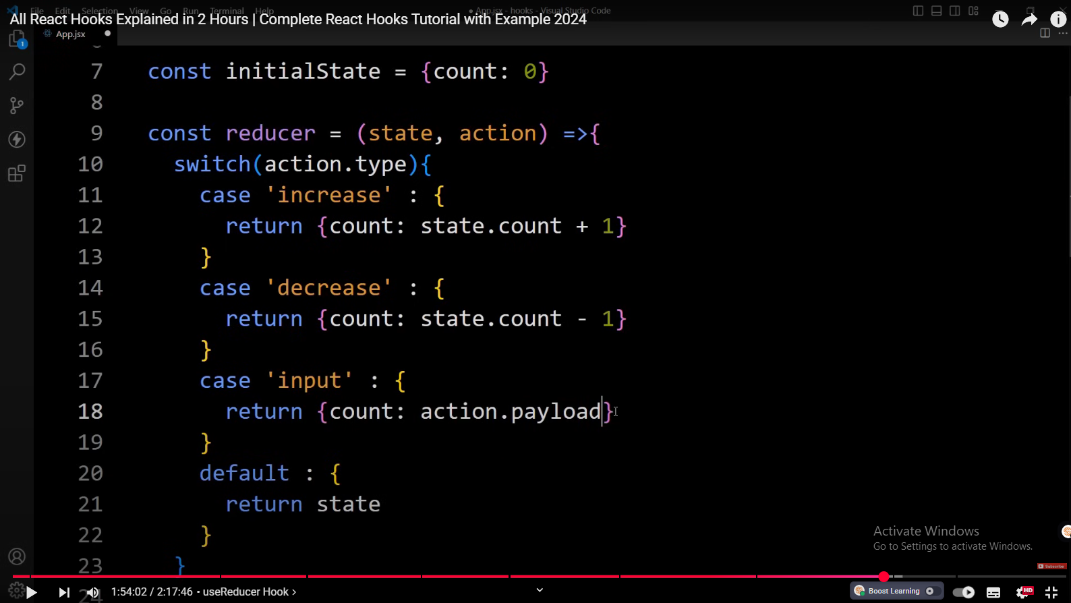

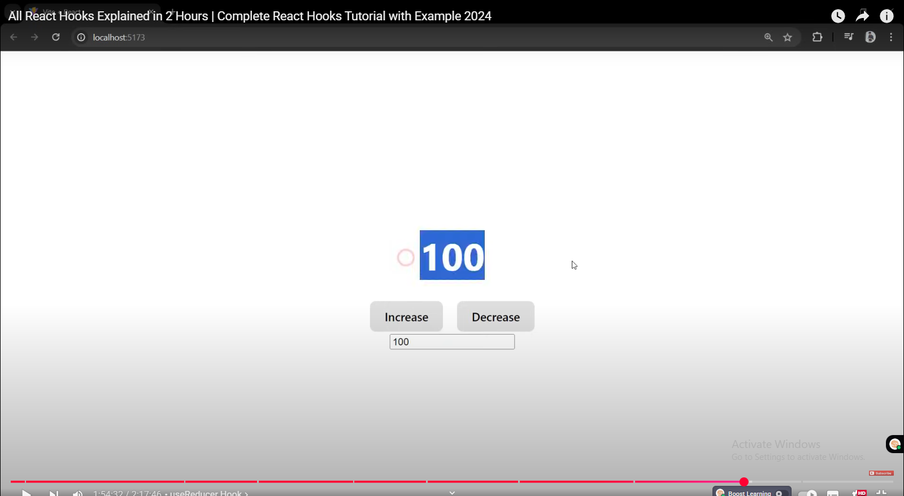

When weare writing something in input , the same number is displayed on count

this is how you can use the use reducer hook to manage the

1:54:50

state when we use the use State hook we directly update the state variables

1:54:57

using the setter function but when we use the use reducer hook we can efficiently

1:55:04

update the state variable for different action so this is all about the use reducer hook in

1:55:11

react now we will learn about use layout effect hook use layout effect works

# UseLayoutEffect Hook

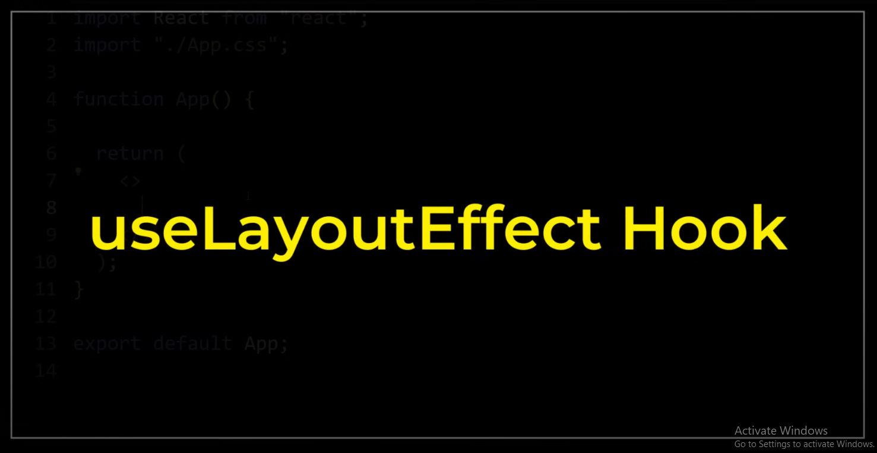

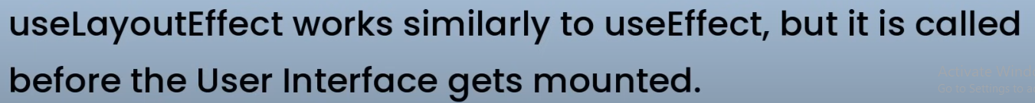



similar to use effect but it is called before the user interface gets mounted

1:55:26

it means the use effect gets called after printing the Dom element but use

1:55:33

layout effect gets called before printing the Dom elements for example if you create a

1:55:40

layout using Dom elements and want to change the layout color using the use

1:55:47

effect hook then first it will display the Dom element and and after that it

1:55:53

will change its color that will cause a blink or flickering issue but when we

1:56:00

will change the color using use layout effect then first it will change the

1:56:05

color and after that it will display the Dom element on the web page let's

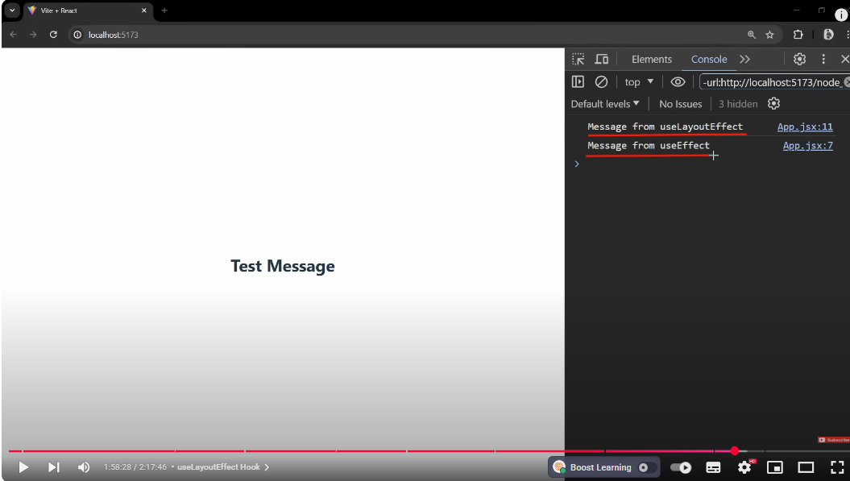

Although you can see in code , code for useEffect is written first , this useLayoutEffect executed before printing h2

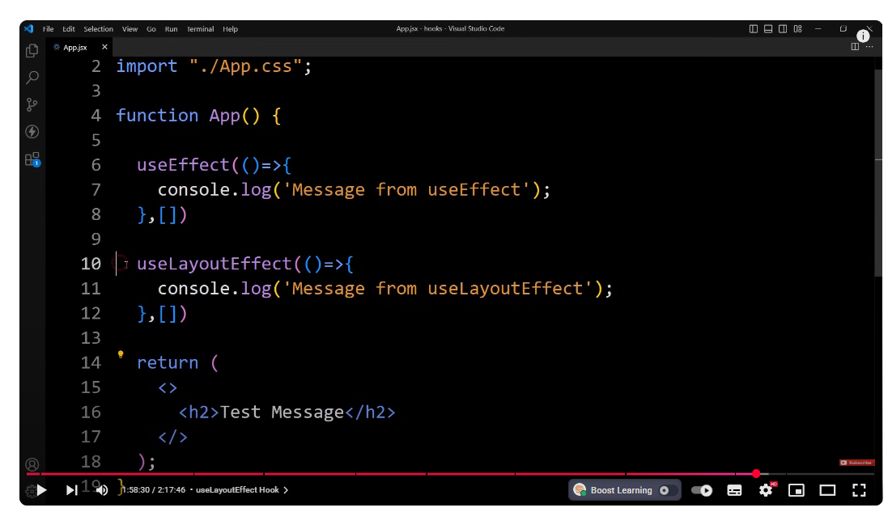

you can see first we have added use effect which is here we have added use

1:58:09

effect and after that we have the use layout effect but in the console it is

1:58:14

printing this message first and after that it is printing this message let me

1:58:19

show you the console again you can see message from use layout effect and after

1:58:26

that we have message from use effect so now you can see the use layout effect is

1:58:32

executed before this use effect and this use layout effect is actually executed

1:58:39

before printing this S2 so first it is calling this use layout effect and after

1:58:46

that it will print this Dom element which is S2 and after that it will

1:58:51

display this message in console which is use effect because this use layout effect is called

1:58:59

before mounting this UI element and this use effect is called after mounting this

1:59:06

UI element right now if I refresh the web page you can see it is printed very

1:59:11

quickly so you can't see the difference so let me add some calculation here that

1:59:16

will take time to print this UI element

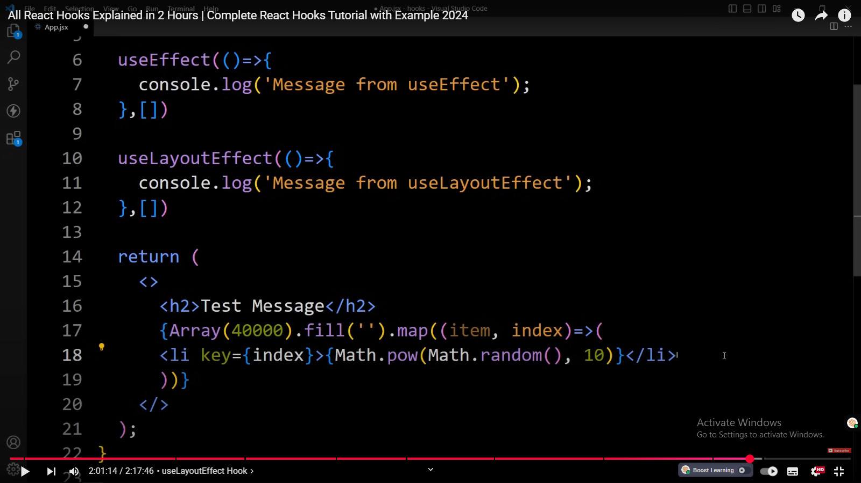

so let me add one add

1:59:25

aray in this array I'll add 40,000

1:59:31

and fill this array with empty

1:59:38

string and on this one we'll add the map method we will map each element of this

1:59:46

array in this map we will add Arrow function

1:59:53

and here we will add individual item and

1:59:59

index and here we will print the LI

2:00:09

tag right and in this Li tag we will display random numbers so first we will

2:00:17

insert this index in this Li so just add key

2:00:23

index let me add it in new line like this now in this Li tag we

2:00:30

will display the random numbers so just

2:00:35

add math do random and uh after that we will add the

2:00:44

power 10 of this random number so it will be a heavy calculation so let me

2:00:50

add like this math.

2:00:56

power and inside this one we will add math. random comma 10 so it will

2:01:02

generate one random number and it will add the power 10 and it will be printed

2:01:08

for 40,000 times so this UI rendering will take time so now we can see the

2:01:15

difference so first it will print this message message from use layout effect

2:01:22

after that it will print this Li elements where it will print random

2:01:28

numbers for 40,000 times and after that immediately it will print this message

2:01:35

from use effect so let me save the changes and open the web

2:01:41

page you can see first it prints this message message from use layout effect

2:01:47

after that it prints this random numbers and after that it will print this

2:01:52

message message from use effect let me clear the console refresh this website

2:01:59

again so here we have the message from use layout effect after that it will

2:02:04

update this here now we have different random numbers and after updating this

2:02:11

UI it is displaying this message from use effect you can see here we have the

2:02:17

number 5124 like that if I refresh the web page let me clear the console

2:02:23

refresh the web page first we have this message after that it is updating this random numbers

2:02:31

and after that it is printing this message which is message from use effect so now you can clearly see use

2:02:39

layout effect is called before rendering the UI element and this use effect is

2:02:46

called after rendering the UI elements we can use the Ed layout hook for

2:02:52

measuring Dom elements and for animating the elements and for fixing the

2:02:59

flickering issue and we can also use it for API calling but react official document says

2:03:08

use layout effect can hurt the performance of app that's why it is

2:03:13

recommended to use use effect Hook when possible so this was all about use

2:03:19

layout effect hook in react now we will learn custom hook in react

# Custom Hook

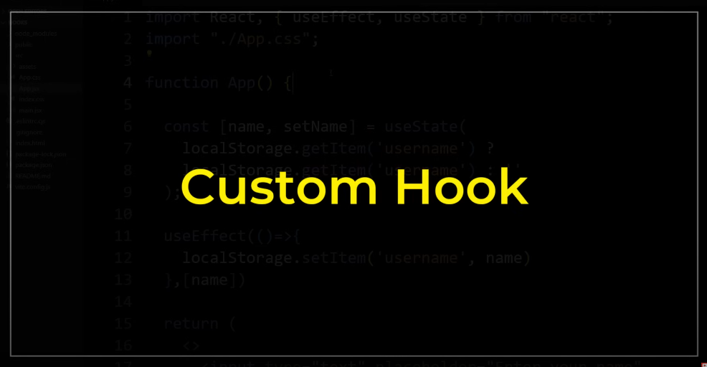

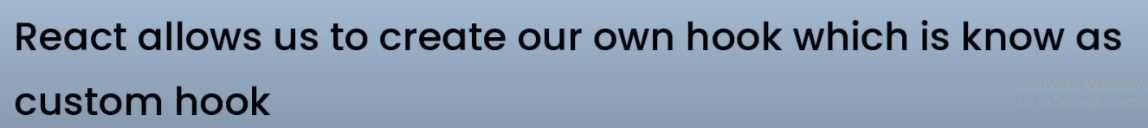

react allow us to create our own hook which is known as custom hook so why we

create a custom hook let's suppose you have a component logic that need to be

used by multiple components so we can extract that logic to create a custom

hook let's understand the custom hook with an example here in this app component I

have added one input field and then we have one title in S2

here we are displaying hello and the name and this name is coming from this

state variable we have name and set name and

we have created it using the US state here we have added the use effect

in this use effect we are adding local storage do set item with the key

username and value is the name this name is coming from this

state and it will be executed every time when this name changes because in this

dependency we have added the name state so it will update the name in the local

storage data in the browser now what is happening here here

we have added set name and in this set name I have added this e. target. value

it means it will set the name using this input field value so whenever we'll add

the new name or change anything in this input field it will update this name

State and it will update the name in the local storage using this use

effect so this logic will update the data on the local estor of web browser

and this use state will get the data from the local storage whenever we will

reload the web page so here we have added the Turner operator it will search

for this local storage get item we are adding get item so it will find this

local storage with this key key is username so it will find

the data in the local storage with the key username if it it is available it

will set that one in this name if it is not available in that case it will add

empty string in this name right so let me show you this on the web

page you can see if I reload the web page here we have the input field and

here we have the hello and there's no name here but if I open

the dev tool click here go to

application and click on this local storage then click on this Local Host so

here you can see one key which is username because this use effect will

add one data in the local storage with the key user name and in this name it will

add this empty string right now if I add some name here

let me add greatest tag so this Greatest Tag is displayed on

the web page also and it is saved in this local storage with the key username

so the username is greatest tack in this local storage now when we will reload

the web page you can see this great St is displayed

here because when we reload the web page it will find the data in the local

storage and if the username is available it will display that here using

this turn operator it will find this local storage G items by username if it

is available it will display the data and if it is not available then it will

display empty string so this logic is working now

suppose you have to add one more State like this you have to add ID then again

you have to create one state like this then you have to add the use effect

right or suppose you have to use this local storage set and get functionality

in multiple components then in the multiple components you have to write this code so to solve this one we will

use the custom hook where we will add these logic and we can simply use that

in different component right so to create a custom

hook we have to add the hook name and that will start with use for example use

State use effect so like that we can add any name like use

fetch so let me create a folder in this

SRC and write the folder name hooks

and in this folder we will create a new file and the file name will

be use local

storage because we are adding the local storage functionality so the file name

is use local storage. jsx here we will add R

fce like this now let's come back and let's remove

this logic we will cut it from here and paste it in this

one like this now we can use this use local storage in

another component so whenever we will call this use local storage we will pass

some arguments so here let's add the parameter key that

will be stored in the local storage and with this key we will pass the initial

value also so let's add initial

value now instead of this username we will provide this

key so remove this and provide key like

this so it will search the local storage if any data is available with

this key then it will display the data or it will display the initial value so

let me copy this initial value and paste it here like this so this will retrieve

the data from the local storage and this use effect will set the data in local

storage so in this one we will provide this key

here and here we will add key so this use effect will be

executed whenever the name State changes or whenever the key changes this will

execute this use effect that's it and here we

have return a statement so in this one we have to return one array

and in this array we will return this state which is name and we will also return this set

name that's it save the changes now our

custom Hook is ready in this custom hook we are accepting two parameters key and

initial value and using this key it will

retrieve the data from the local storage and using this key it will store the

data in local storage by using this line local storage do set item key and this

name name is here and after that it will return the

updated estate name and this set function set name now we can use this

custom hook which is use local storage just copy this one open app.jsx

file here we can remove this use effect use state it is not required

now and here we can use our custom hook so let's

add use local storage it is here so the use local storage has been

imported right now in this one we have to provide

the key and initial value so let me provide the key using

name and the initial value will be empty string and here it will return two value

the first one will be data from the local storage and the second one is seter function so let me store

it in one add a so the first one is name

and the second one set name like this so this name will be

displayed in this title and this name value will be added

in this input field also and this set name is used here in set name that will

update the data in the local storage let me save the changes and open the web

page so here we have some error let me come back and open this local storage

you can see in this one we have used use State and use effect and we have not

imported it so just we have to import it from

react use a state and use

effect that's it save the changes open the web page now we have the input field

and message greatest tack let me clear this so you can see the local storage is

clear here there is one key username and the value is

empty if I refresh it still the value is empty if I type

something you can see the same value is saved in this local storage with the key

username and the value ainash Let me refresh it still it will

fetch the data from the local storage and display it here so now you can see we have added

this local storage feature using this single line that's it now suppose I have to add one

more data in the local storage so how we can do that let me add the same line

again and we will store ID and this will be set ID

and uh here we will add user

ID and initial value will be empty and uh let me display this ID on

the web page so duplicate this here we will add the input field enter your

ID let's add value ID and here set ID Setter function set

ID and here we will update the message your

ID and provide this ID State that's it

so we have just used this ID and set ID in this element and added this single

line that uses the custom hook and we are providing the key and initial value

that's it if I save the changes open the web page you can see we have another input field right now the data is empty

in this input field and your ID and the ID is empty so now if I type something 1

2 3 you can see this 1 123 is stored in this local storage with the name user ID

and the value 1 2 3 and here it is displaying your ID 1 23 remove this

comma now it is looking good if I reload the web page still we have this because when

we reload the web page it will fetch the data from the local storage and it will

display it in this input field and in this title also so now we can use the

local storage feature by using this custom hook we can use this use local

storage custom hook in any component this is how we can create and use the

custom hook in our react application now we have completed almost commonly used

react hooks I hope this video will be helpful for you if you have any question

you can ask me in the comment section please like and share this video and also subscribe my channel great stack to

watch more videos like this one thank you so much for watching this video

